**Leadership Excellence**



Sriram

Digital Leader

# About Sriram



I have been involved in IT Software development since 1997. I have unique combination of process, technical and industrial skills. As a Digital Leader, I have an expert level of knowledge in agile and practices with this combination I can help process and technology people, understand the agile world.

The “**Leadership Excellence”** book comprises of Leadership activities. One in All, All in One & Key to Success.

My agile journey started in 2011, when I was a part of Tata Consultancy Services. I practiced scrum and agile methods thoroughly over several years and my teams are highly successful in delivering products using agile techniques.

I am proficient in agile engineering, coaching practices and SAFe consulting practices. I have more than 5 years of experience as a senior architect cum senior manager in development. I religiously follow key agile engineering practices like TDD, Refracting, CI and Collective Ownership. Worked in USA, UK for TCS, AtoS, Cognizant & IBM - Agile customers, which creates a global agile experience.

I moved back to India in 2016 and created agile websites and released books related to Scrum Alliance Professional, Agile Coaching and Implementing SAFe 5.0 practices.

Throughout my agile journey, I have been associated the agile professionals, who have helped and mentored me in the journey where sky is the limit.

Place: Dubai, UAE – Middle East Email: digitalcloudguru@gmail.com

B sriram

# Table of Contents

Contents

About Sriram 2

Table of Contents 3

1.Introduction to Leadership 4

2. Leadership Traits, Knowledge, Skills & Abilities 19

3. Leadership Theories 25

4. Leadership Power and Influence 39

5. Team Leadership 55

6. Organizational Leadership 58

7. Leadership Character & Ethics 61

8. Leadership Management Style 73

9. Leadership Communication 75

10. Leadership Habits 79

11. Leadership Responsibilities 82

12. Digital Leadership 89

# Introduction to Leadership

**What is Leadership Excellence ?**

* Leadership Excellence means being on the right path towards which is better, more successful to achieve the best goal. To achieve this, leader should be committed to development and improvement and be aware all of key success factors.
* Leader must know what should be changed and how the change is to be implemented and need to be going ahead on the right path towards the milestone with commitment to the team and organizations



**Give an example for Leadership Role?**

|  |  |  |
| --- | --- | --- |
| Entrepreneur  President  CEO, COO, CFO CIO  Chief Delivery Officer  Chief Digital Officer  Vice President  Director | Coach  Strategic Planner  Problem Solver  Resource Allocator  Negotiator  Change Agent  Innovator | Visionary  Team Builder  Liasson  Spokesman-Communicator  Figurehead |

**What is Leadership?**

“The action of leading a group of people or an organization.”



* Leadership is the ability of an individual or a group of individuals to influence and guide followers or other members of an organization
* Leadership involves developing a strategy, planning goals and desired outcomes, and giving meaningful direction to one or more individuals so that they may perform the needed tasks and duties designed to support achieving these goals and outcomes
* A leader has the capability to influence others to understand and support a collective, shared purpose, and assist with the tasks and activities needed to be performed
* A leader effectively facilitates the efforts of their followers through a combination of social and interpersonal skills, expertise in a specific area or field, and dedication to a particular mission and purpose, to accomplish a shared objective
* Leadership encompasses the ability to inspire confidence among their followers so that they may support the leader’s vision and mission.

**What is the difference between Leadership & Management?**

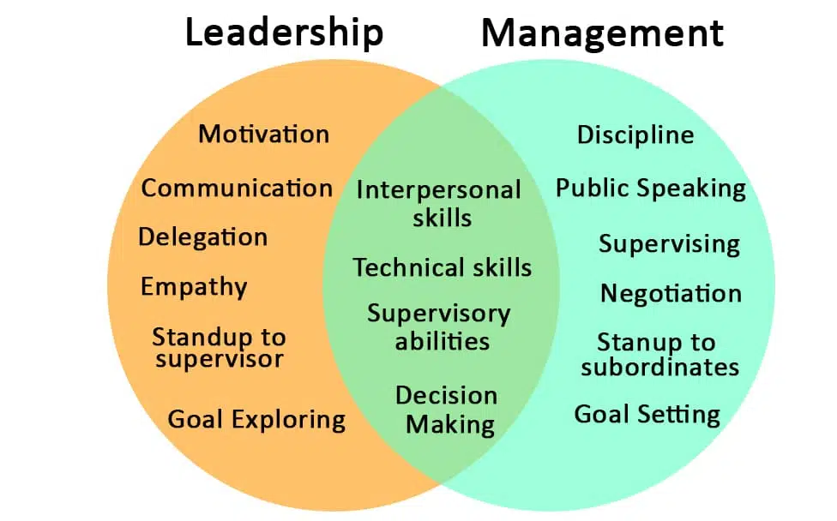

**Leadership** is about taking risks and challenging the status quo. Leaders motivate others to achieve something new and better. Interestingly, leaders do what they do to pursue innovation, not as an obligation. They measure success by looking at the team’s achievements and learning.

**Management** is about delegating responsibilities and getting people to follow the rules to reduce risk and deliver predictable outcomes. A manager is responsible for completing four critical functions: planning, organising, leading, and controlling.

Unlike leaders, managers do not challenge the status quo. Instead, they strive to maintain it. They evaluate success by seeing if the team has achieved what was expected.

**Leaders and managers apply different approaches to achieve their goals**. For example, managers seek compliance to rules and procedures, whereas leaders thrive on breaking the norm and challenging the status quo. Here’s how leadership and management are different from each other.

**Vision**

Leaders and managers have different visions. Leaders are visionaries, whereas managers are implementers. Leaders set goals for their team. Managers ensure that the goal set by their superiors is achieved.

**Organizing vs. Aligning**

Managers achieve their goals by delegating responsibilities among the team. They tactically distribute work among subordinates and organize available resources required to reach the goal.

Meanwhile, leaders motivate people. They concentrate on the personal development of their team besides working towards achieving organizational goals. They envision their team’s future growth and work towards achieving that.

**Analyzing and Assessing**

A leader analyses and assesses every situation to achieve new and better results. Whereas a manager does not analyse or evaluate, they emphasize on questions like how and when, which assists them in achieving the goals. They accept and strive to achieve the status quo.

**What are the different ways to succeed as a great leader?**

* Inspiring Commitment
* Leading Employees
* Strategic Planning
* Change Management
* Employee Development
* Self-Awareness

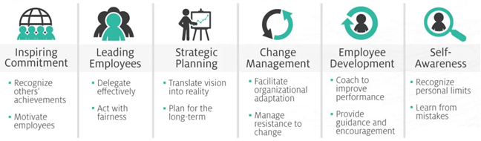

**What are the characteristics of Leadership?**

* Planning and Vision
* Effective and Efficient Communication
* Decision Designer
* People Skills
* Competence
* Innovation and Change
* Relationship and power
* Bold, Courage & Risk
* Serving Heart as a Servan Leader
* Self-Management

**What Are the 12 Qualities of a good Leadership?**

1. **Honesty and Integrity:** Leaders value virtuousness and honesty. They have people who believe in them and their vision.

2. **Inspiration:** Leaders are self-motivating, and this makes them great influencers. They are a good inspiration to their followers. They help others to understand their roles in a bigger context.

3. **Communication skills:** Leaders possess great communication skills. They are transparent with their team and share failures and successes with them.

4. **Vision:** Leaders are visionaries. They have a clear idea of what they want and how to achieve it. Being good communicators, leaders can share their vision with the team successfully.

5. **Never give-up spirit:** Leaders challenge the status quo. Hence, they never give up easily. They also have unique ways to solve a problem.

6. **Intuitive:** Leadership coach Hortense le Gentil believes that leaders should rely on intuition for making hard decisions. Especially because intuition heavily relies on a person’s existing knowledge and life learnings, which proves to be more useful in complex situations.

7. **Empathy:** A leader should be an emotional and empathetic fellow because it will help them in developing a strong bond with their team. Furthermore, these qualities will help a leader in addressing the problems, complaints, and aspirations of his team members.

8. **Objective:** Although empathy is an important quality a leader must imbibe, getting clouded by emotions while making an important business decision is not advisable. Hence, a good leader should be objective.

9. **Intelligence:** A good leader must be intelligent enough to arrive at business solutions to difficult problems. Furthermore, a leader should be analytical and should weigh the pros and cons before making a decision. This quality can be polished with an all-inclusive leadership training program.

10. **Open-mindedness and creativity:** A good leader is someone who is open to new ideas, possibilities, and perspectives. Being a good leader means understanding that there is no right way to do things. Therefore, a good leader is always ready to listen, observe, and be willing to change. They are also out-of-the-box thinkers and encourage their teams to do so

11. **Patient:** A good leader understands that a business strategy takes time to develop and bear results. Additionally, they also believe that ‘continuous improvement and patient’ leads to success.

12. **Flexible:** Since leaders understand the concept of ‘continuous improvement, they also know that being adaptable will lead them to success. Nothing goes as per plan. Hence, being flexible and intuitive helps a manager to hold his ground during complex situations.

**What are the 12 disciplines of Leadership Excellence?**

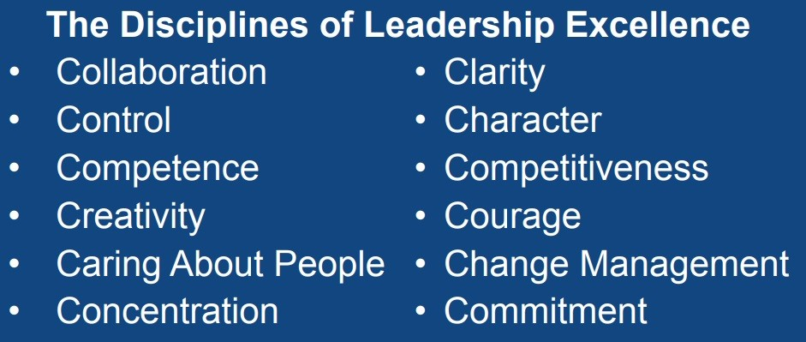

**1. Discipline of Collaboration**

Leaders ensure that people work well together in synergistic teams and are aligned with the unity of vision, values, and objectives. They create a positive and fun culture of cooperation among their people. They hire and retain the best people, and they enable participative leadership, employee engagement, and strategic partnerships.

**2. Discipline of Clarity**

Leaders take the time to become absolutely clear about their values, vision, mission, purposes, goals, strategies, tactics, priorities, strengths and passion in every part of the business, and in personal life. They communicate clearly and effectively with people.

**3. Discipline of Control**

Leaders practice high levels of self-mastery and self-control in their actions and interactions with others, and both take charge and remain in charge of the situation. They are willing to make sacrifices for the good of their people.

**4. Discipline of Character**

Leaders practice honesty and integrity in everything they do, making promises carefully, but then keeping their promises. They passionately build trust among their people with a strong sense of ethical quality and humility

**5. Discipline of Competence**

Leaders never stop upgrading their knowledge and skills through continuous reading, listening, watching, and learning on every occasion. They work very hard to become extremely good at what they do and are dedicated to continuous improvements. They cultivate the same philosophy of continuous learning and development with their people.

**6. Discipline of Competitiveness**

Leaders are highly competitive and are determined to succeed by marketing and selling better products and services, aggressively in any market. They are customer-centric and have strong strategic acumen in creating a competitive advantage to win over their competitors.

**7. Discipline of Creativity**

Leaders spend most of their time finding solutions to problems. The ability to deal with difficulties will, more than anything else, determine what happens in your career. Those with poor creativity are always delegated to working for those with strong creative thinking skills.

**8. Discipline of Courage**

Leaders demonstrate courage by moving out of their comfort zones, being willing to embrace adversity, make tough decisions, and take risks with no guarantee of success.

**9. Discipline of Caring about People**

Leaders recognize that their people are their most important assets and that kindness, courtesy and consideration are essential to bringing out the very best in the people who work for them. They are servant leaders that touch the hearts of people with care and sincerity while adding value to them.

**10. Discipline of Change Management**

Leaders are expected to handle the challenges of change more cleverly than everyone else. In this VUCA world, change is inevitable and mostly unpredictable. The better you can deal with changes in your business and personal life, the greater your contribution will be, and the more valuable you will be to the organization.

**11. Discipline of Concentration**

Leaders manage their time well, set clear priorities on the use of time and resources, and concentrate single-mindedly on one thing at a time. They use the power of focus to do the right thing at the right time and to leverage their strengths to achieve sustainable success.

**12. Discipline of Commitment**

Leaders are fully committed to the achievement of goals, winning, and the success of their businesses or departments. They have a strong sense of responsibility and determination to achieve results.

**Leader-Follower Partnership**

Leadership requires both a leader and followers, and an effective leader understands the importance of developing and maintaining a partnership with their followers to work collaboratively, productivity and harmoniously.

**What are the 51 rules of Leadership Excellence?**

Live by them and the successful, influential leader in you will take you far in life and business.

1. Take responsibility; never, ever place blame elsewhere.
2. If you want to control your future, let go of the control.
3. Learn to be a strong communicator. No, this does not mean send a lot of text messages.
4. Listen, don't judge.
5. Don't make excuses; when it comes to being a respectable leader, there are none.
6. Never forget that your team, not your product, not your bank account, is your number-one asset.
7. Give your team the tools and freedom to be extraordinary. There is no better investment.
8. If you promise to do something, do it--and do it well.
9. Let your ego know that it's really smart to surround yourself with people who know more than you do.
10. To work with a coach or mentor is a sign of a successful mindset, not a weakness.
11. Consciously build a powerful company culture. Otherwise, it will build itself and you probably won't like the results.
12. If you consistently work through the night, you're doing something wrong.
13. Employee meetings are not a disruption, waste of time, or inconvenience.
14. Never enter into a 50-50 partnership.
15. Do not launch a product without doing market research that goes well beyond family and friends.
16. Before you even think about stepping into a leadership role, define and understand your values. Otherwise, you have no road map to lead yourself or others to success.
17. You are only as successful as you believe you are. Mindset is everything.
18. Don't think your idea is a great one because you believe in it and you've worked hard for it. It's only great if your customers believe it too.
19. Honesty is a code to live by; choose your words carefully.
20. If you think it's time to quit, it probably is.
21. Make friends with your numbers, even if you don't like them very much.
22. Don't jump into a partnership because you're excited. Partner because you have a great idea, the combined skills to make it happen, and a viable plan in place. Then see a business lawyer.
23. Always stay in check in social media. Yes, even on your personal accounts.
24. Don't take advice from people who haven't been there, done it, and succeeded.
25. Only borrow money from friends and family who are willing to lose every penny of it and not hold it against you.
26. Build your personal brand even if you think you don't matter to your customers--because you do.
27. Don't wear your overwhelming schedule as a badge of honor. Be proud when you can get everything done and have plenty of time to enjoy life.
28. It's only a failure if you beat yourself up for it instead of learn from it.
29. You have to believe in yourself before anyone else will.
30. It's alright to have self-doubt. It's not alright to let it consume you.
31. Experiencing fear is natural and normal. Allowing it to keep you from your dreams is just sad.
32. Don't make the mistake of believing you can be a full-time parent and achieve your business success on the timeline of a single person.
33. Stop saying that there's never enough time; there is if you stop doing the things that a real entrepreneur doesn't do.
34. Know your strengths and don't dwell on your weaknesses. Just hire someone to fill the gaps.
35. If you believe that you can't afford to do something to the betterment of your business, then you can't.
36. When stress is getting the best of you, place your focus on helping someone else.
37. The customer may always be right, but if they cost you more than they pay you, they are not your ideal customer.
38. There is nothing in the world worth missing your kid's birthday for.
39. Only make friends with your employees if you can put on the boss hat and not feel guilty or uncomfortable in it.
40. If you can't trust your employees, it's for one of two reasons: You are too controlling, or you don't know how to hire right.
41. Ask interview questions that will tell you if your candidate is a good culture fit. Most skills can be taught. Personality, not so much.
42. Take care of you first and you'll have the energy and clearheadedness to take good care of your company.
43. Meditation isn't just for hippies anymore.
44. Never forget the healing power of laughter.
45. If you hold on to poor performers, you are the one who needs improvement.
46. Don't exhaust yourself grabbing at nickels and dimes. Know where the real profit comes from.
47. Always give back.
48. If you're in it just for the money, you'll never know true success.
49. Without a vision, you can't get there. But remember, your vision matures as you do.
50. Angel investors aren't really angels.
51. Don't shut off your emotions. They aren't in the way; they are there to help pave the way.

**What is Formal & Informal Leadership?**

An informal leader is a person who is leading but who, at the same time, doesn’t have the official powers to lead the group. The formal leader, on the contrary, has been given authority based on their position in the group.

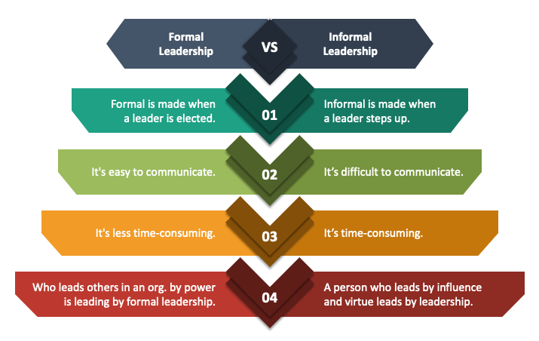

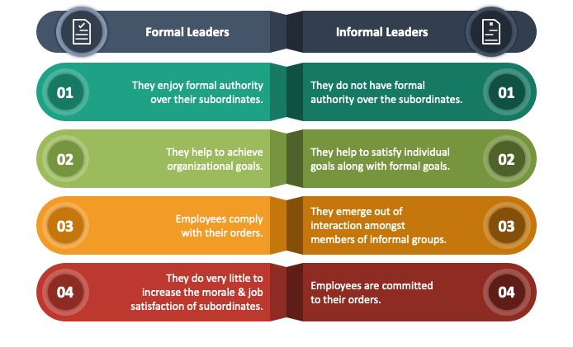

**What is Progressive leadership?**

Progressive leaders are those who look outside of just their organization and have a greater view. They look at potential problems and turn them into opportunities. They must consider the welfare of their workforce and customers before anything else. There are certain qualities that a progressive leader will possess, and this includes:

**Setting the example**: setting an excellent example of leadership allows you to set the stage for the type of leadership you expect and want to see in your business. It also creates an expectation that you want others to follow.

**Sharing their vision**: what exactly is your vision for the future of your organization? You can’t expect your workforce to follow if they don’t believe or understand it. Collaboration is essential, it reassures everyone is on the same page and all working towards achieving the same goal.

**Celebrating success**: honoring success shows gratitude to those who achieve it. People are motivated by their successes. Recognizing victory reinforces those actions and in turn results in this being repeated by the overall organization.

# 2. Leadership Traits, Knowledge, Skills & Abilities

**What are Leadership Traits? What makes an Effective Leader?**

A trait is a particular characteristic, quality, or tendency that someone or something has. Traits provide a valuable component for research on leadership that yielded significant findings regarding the impact and importance of specific traits and characteristics on effective leader performance and outcomes.

A leader’s traits must be relevant to the setting and context in which they are performing, and their effectiveness depends on how well those traits enable them to apply their knowledge, skills, and abilities to demonstrates the behaviors needed for high performance and outcomes.

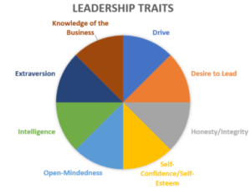

**Drive**

Leaders tend to be highly motivated individuals. This inner drive is reflected in a number of common ways. They reflect a greater effort level in general, they strive for achievement, they have greater ambition, they work with greater energy, they are often tenacious, and they are more likely to take the initiative rather than wait for someone else to do so.

**Desire to Lead**

Effective leaders also tend to have a strong desire toward leadership roles and functions. Although others are happier to allow others to take the lead, leaders want to do so themselves.

**Honesty/Integrity**

The moral aspect of leadership is highly significant. Effective leaders must demonstrate high levels of honesty and integrity. This is essential to inspiring confidence and trust from employees and other followers, without which a leader is not likely to be effective. Dishonesty may not always be revealed at first, but it usually is with time. There are many stories of business leaders who are successful for a period of time but later find themselves in serious trouble due to dishonest or unethical practices. For example, Martin Winterkorn became embroiled in ethical and legal controversy after a period of strong success as CEO of Volkswagen.

**Self-Esteem /Self-Confidence**

These two elements, self-esteem and self-confidence, are closely related and tend to be prominent in leaders. Perhaps it is best to view these traits in terms of the negative perspective. A lack of self-esteem and self-confidence is very problematic for a leader. When these traits are lacking, doubts arise and insecurities plague a leader’s activities. The leader tends to be confident that his beliefs, plans, and actions are correct (hopefully with good reason). This confidence is important in that it enables the leader to persist steadfastly in the right course even when there are obstacles and doubts from others.

**Open-Mindedness**

At the same time, effective leaders also tend to be open-minded to new ideas and experiences. They recognize that innovation is often valuable, and they also tend to consider ideas and suggestions from others. Self-confidence and self-esteem do not have to conflict with this spirit of open-mindedness. When they do, the result is generally harmful.

**Intelligence**

One obvious trait that many people look for in leaders is intelligence. Studies have shown that this is indeed an important qualification. It has been suggested, however, that pure cognitive ability is a “threshold” qualification. That is, it is important for the entrance into leadership roles. However, once within the leadership circle, most individuals have relatively high intelligence levels, so mere cognitive ability is not enough to distinguish a leader from other leaders.

Further, pure cognitive ability is only one type of intelligence. Relational and emotional intelligence are also important aspects for leaders to develop. An over-reliance on strict cognitive intelligence can be very inhibiting to effective leadership.

**Extraversion**

Another unsurprising personality trait that is commonly associated with leadership is being an extrovert. Leaders tend to be outgoing and social in their personalities, which helps them take the lead and act with initiative. It also helps them with the important aspect of connecting to and inspiring others through relationships.

Though many leaders are extraverts, there are certainly examples of successful leaders who are not. Sometimes other strengths are sufficient to compensate for not being an extravert, or sometimes a leader who is not naturally an extravert is able to train himself to be more outgoing in behavior when needed, though this still does not generally change the leader’s basic personality. Bill Gates of Microsoft and Mark Zuckerberg of Facebook are two prominent examples of extremely successful leaders who are introverts by personality.

**Knowledge of the Business**

Another key ingredient in the leadership trait mix is knowledge of the business. Even if an individual has all the natural personality traits desired of leaders, a lack of knowledge and experience is usually impossible to overcome. A leader must be competent in his field, and the most effective leaders are usually experts with deep insight.

**What are Leadership Knowledge, Skill & Abilities (KSA)?**

**Knowledge** is the level of education, experience or training that an individual must have at a minimum to be considered qualified for a role. For example, some job advertisements may state that they are willing to accept graduates for a role, while others may state that the applicant must have 5 years of experience in a similar role. Knowledge can be further described as the theoretical or practical understanding of a subject, or the ability to apply the information to different situations.

A **Skill** is something learned through experience. It is used to carry out complex activities or job functions to achieve pre-determined results. A skill is not an innate behavior and must be developed and improved with practice. A skill can be developed through getting specific training or learning as you go, but always starts off as unfamiliar.

The 3 categories of skills are: - Technical, Human & Conceptual

**Technical Skills**

Having relevant breadth and depth of knowledge, as well as the ability to perform tasks and functions in the areas of: -

* Operations
* Process, Workflow & Methods
* Equipment
* Technology Tools & Systems
* Methods and Techniques for performing tasks

**Human Skills**

* Developing and forecasting positive interpersonal relationships
* Communicating clearly with focus and purpose
* Acting as a coach and advisor to followers, investing in their development and growth
* Demonstrating objectivity and fairness to resolve conflicts and challenges
* Inspiring followers to contribute towards shared goals by serving as a motivational influence
* Enabling followers to whole-heartedly share ideas and provide input without any judgement

**Conceptual Skills**

* Developing a vision that depicts a tangible an appealing improvement to a situation or need
* Having insight to forecast trends and patterns and anticipated changes
* Seeing opportunities and generating ideas for how to make them a reality
* Planning a strategy and both short and long-term goals
* Possessing critical and analytical thinking, logic and reasoning
* Making informed and timely decisions even without sufficient information | facts | any resources

**Skill Model of Leadership**

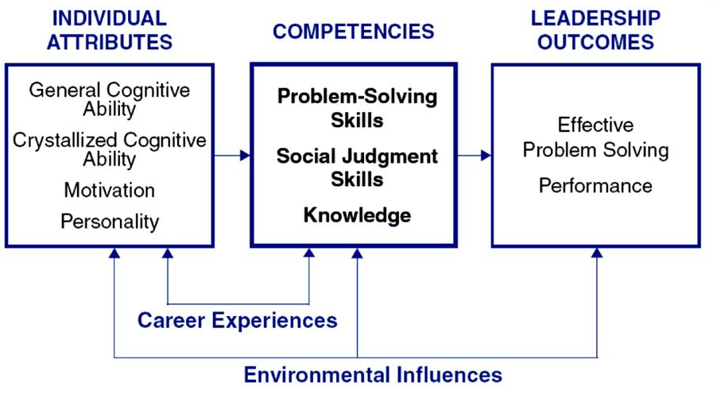

**Ability** is an innate quality that one ‘does’ or ‘does not’ possess, ability is not something that can be learned or developed unless it is there to begin with. Simply, abilities are the qualities needed to perform certain behaviors and whether someone is able or not is dependent on their pre-existing qualities. You can think of this much like potential.

KSC produces unique but equally important skill categories including technical, human and conceptual skills. The research emphasized the alignment between leader traits and KSA’s in conjunction with their experience, and generated focus on the idea that leadership could be developed through the proper education, skill-building and coaching, resulting in the achievement of the desired performance outcomes.

# 3. Leadership Theories

**What are Leadership Theories?**

Leadership theories are schools of thought brought forward to explain how and why certain individuals become leaders. The theories emphasize the traits and behaviors that individuals can adopt to boost their own leadership abilities.



A leader is crucial to the success of every team. Take an orchestra, for instance, one that consists of all the best musicians in the world but lacks a conductor. Even though every member of the orchestra can play perfectly by themselves, they will only produce an incompatible melody in the absence of a conductor. The same concept applies to communities, companies, and countries. Without a leader, nothing will ever run smoothly.

So, what makes leaders who they are? Why are some people elected as managers and presidents while the rest remain followers? Leadership theories were developed to find answers to these questions.

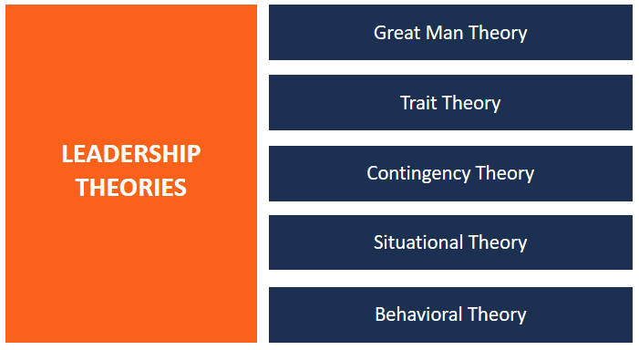

**Key Leadership Theories**

**1. Great Man Theory**

According to the Great Man Theory (which should perhaps be called the Great Person Theory), leaders are born with just the right traits and abilities for leading – charisma, intellect, confidence, communication skills, and social skills.

The theory suggests that the ability to lead is inherent – that the best leaders are born, not made. It defines leaders as valiant, mythic, and ordained to rise to leadership when the situation arises. The term “Great Man” was adopted at the time because leadership was reserved for males, particularly in military leadership.

**2. Trait Theory**

The Trait Theory is very similar to the Great Man Theory. It is founded on the characteristics of different leaders – both the successful and unsuccessful ones. The theory is used to predict effective leadership. Usually, the identified characteristics are compared to those of potential leaders to determine their likelihood of leading effectively.

Scholars researching the trait theory try to identify leadership characteristics from different perspectives. They focus on the physiological attributes such as appearance, weight, and height; demographics such as age, education, and familial background; and intelligence, which encompasses decisiveness, judgment, and knowledge.

**3. Contingency Theory**

The Contingency Theory emphasizes different variables in a specific setting that determine the style of leadership best suited for the said situation. It is founded on the principle that no one leadership style is applicable to all situations.

Renowned leadership researchers Hodgson and White believe that the best form of leadership is one that finds the perfect balance between behaviors, needs, and context. Good leaders not only possess the right qualities but they’re also able to evaluate the needs of their followers and the situation at hand. In summary, the contingency theory suggests that great leadership is a combination of many key variables.

**4. Situational Theory**

The Situational Theory is similar to the Contingency Theory as it also proposes that no one leadership style supersedes others. As its name suggests, the theory implies that leadership depends on the situation at hand. Put simply, leaders should always correspond their leadership to the respective situation by assessing certain variables such as the type of task, nature of followers, and more.

As proposed by US professor Paul Hersey and leadership guru Ken Blanchard, the situational theory blends two key elements: the leadership style and the followers’ maturity levels. Hersey and Blanchard classified maturity into four different degrees:

M1 – Team members do not possess the motivation or tactical skills to complete necessary jobs.

M2 – Team members are willing and ambitious to achieve something, but they lack the necessary ability.

M3 – Team members possess the skills and capacity to accomplish tasks, but they’re not willing to take accountability.

M4 – Team members possess all the right talents and are motivated to complete projects.

According to situational theory, a leader exercises a particular form of leadership based on the maturity level of his or her team.

**5. Behavioral Theory**

In Behavioral Theory, the focus is on the specific behaviors and actions of leaders rather than their traits or characteristics. The theory suggests that effective leadership is the result of many learned skills.

**How will you apply Leadership Theories at the workplace?**

To a great extent, leadership theories have helped form and shape the kind of governance that exists today. Many aspects of these theories can be applied to help one improve his or her leadership skills.

**1. Maximize Your Strengths**

As proposed by the Trait Theory, effective leadership depends on the traits that one possesses. Leaders should strive to focus on their strengths rather than their weaknesses. The strengths vary from one leader to another and may include:-

* A strong will is crucial to staying resilient and seeing leaders through difficult times. No matter how challenging the situation may be, a strong-willed leader is able to find inner strength and carry on until he or she overcomes all challenges.
* A decisive nature is another strength that some leaders possess. Decisiveness means that when others may be perplexed, a leader can calmly assess the situation and choose one action to unite everyone. But, since they may not always make the right decisions, they must also be willing to learn from their mistakes.

**2. Be Inclusive Leaders**

Some of the more complex situational theories emphasize focusing on people. It means that they acknowledge individual people to be their greatest assets and not just mere numbers in their workforce. Being an inclusive leader requires that one constantly involves other people in their leadership, whether it is by always welcoming the feedback of others or delegating more responsibility to others than other forms of leadership.

**Conclusion**

There are numerous ways of defining leadership. Some leadership theories attempt to explain what differentiates a leader, while some explain how great leaders come to be.

The Great Man Theory believes that the inherent traits that one is born with contribute to great leadership.

Situational Theory recommends leaders to adopt a leadership style depending on the situation at hand, while the Behavioral Theory is all about the learning the skills necessary to become a good leader.

**What are the behavioural best practices of Effective Leadership?**

Leaders should consider the behaviors and approaches below as they continue to develop their own unique leadership style that serves both their followers or group members as well as the goal and task at hand: -

* Start each day by asking, “What needs to be done?” to maintain task and work completion milestones, and follow up by asking, “What can we do to make a difference?” to maintain the focus on the vision
* Understand the needs, concerns and challenges of followers or group members by being approachable and accessible, and maintaining open two-way lines of communication for both listening and sharing information
* Create a climate of inclusion and respect by valuing diversity among followers or group members, appreciating the strengths of individual differences, and encouraging employees to be their unique selves
* Clearly prioritize the goals and their required task needs, aligning with realistic and tangible results, and making adjustments as necessary
* Ensure the current vision and mission continue to be relevant amid shifting trends and needs, make modifications to adapt accordingly, and share with followers or group members to ensure everyone is in sync with short and long time goals and expect outcomes
* Stay accountable for the performance and outcomes of the entire group or organization and take responsibility for any issues that arise – as a leader, nothing is never not ‘their’ fault
* Sustain awareness to behave with integrity and objectivity, demonstrate a strong work ethic, and act as a consistent role model with which followers or group members can resonate

An effective leader will recognize the need for a balance of all of the behaviors within these dimensions and be able to apply their unique attributes to act in a manner that facilitates performance, enables goal achievement, and also serves the needs of the followers.

In addition, a strong leader will understand how to assess a situation and its distinct contextual factors in an effort to implement the most appropriate balance of task-focused and inter-personal relationship focused behaviors needed, which is called Situational Leadership.

**What is the Contingency Theory of Leadership?**

Contingency theory states “that a leader's effectiveness is contingent on how well the leader's style matches a specific setting or situation” (Wolinksi, 2010). If leaders were successful in the roles they played, then it was considered a perfect match.

The contingency theory of leadership puts forth the idea that the success of a leader hinges on the specific situation at hand. Certain factors come into play that define whether a particular leader or leadership style will be effective for the given situation. Those factors include the task, the personality of the leader and the composition of the group that is meant to be led. Its basic assumption is that leadership – success or failure – is situational.

**Contingency Leadership Models**

There are several different models of contingency leadership that fall under the general contingency theory umbrella. They include Fiedler’s Contingency Theory, the Situational Leadership Theory, the Path-Goal Theory and the Decision-Making Theory. While all of these contingency leadership models are similar on the surface, they each offer their own distinct views on leadership.

**Fiedler’s Contingency Theory**

Fiedler’s Contingency Theory puts forth the idea that effective leadership hinges not only on the style used by the leader, but also on the control held over the situation. In order to succeed, there must be strong leader-member relations. Leaders must also present tasks clearly and with goals and procedures outlined. They need to possess the ability to hand out punishments and rewards, as well.

Fiedler’s Contingency Theory only fits situations where groups are closely supervised and not team-based. It also uses a least preferred co-worker (LPC) scale to help determine the type of worker the leader least likes working with. This contingency model emphasizes the leader’s disposition as the main trait that defines the ability to lead.

**Situational Leadership Theory**

More formally called Hersey and Blanchard’s Situational Leadership Theory, this contingency model focuses on leadership style and the maturity of those being led. Situational leadership theory puts forth the idea that leadership styles hinge on four behaviors: telling, selling, participating and delegating.

The maturity levels range from an incompetence or unwillingness to perform the task, to a willingness and ability to perform. The idea is that a successful leader will adapt leadership techniques to fit the maturity level of the group in question on a situational basis.

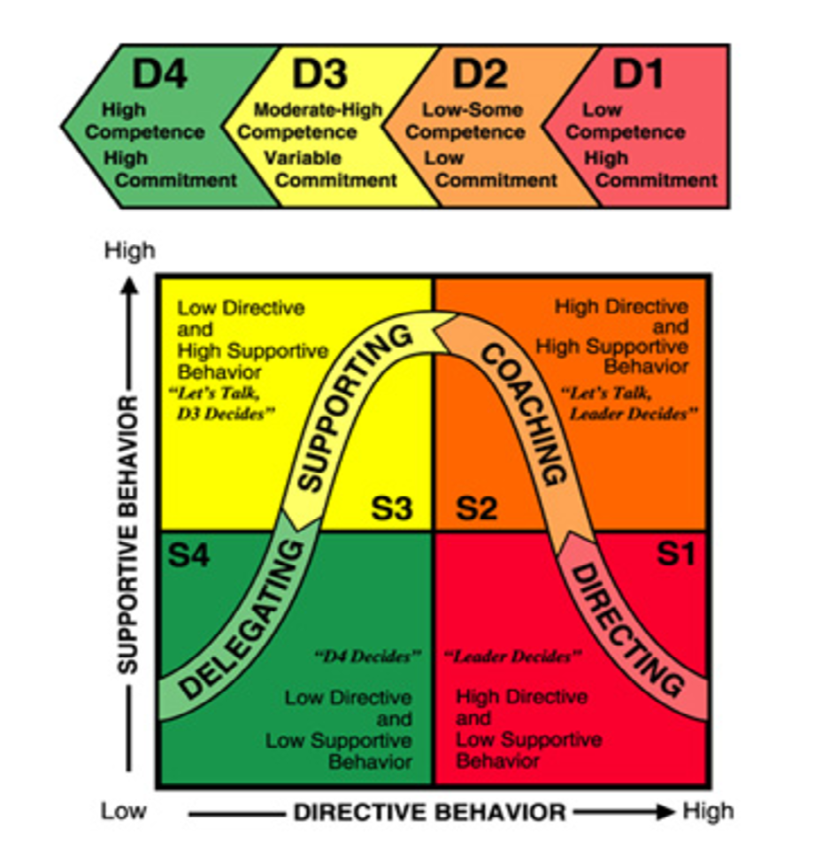

**Path-Goal Theory**

Path-Goal Theory combines two popular theories – goal-setting and expectancy – into one. It puts forth the idea that effective leaders help those in their direction attain their goals. Under this contingency model, leaders have the responsibility of making sure their subordinates have the support and information required to achieve the goals set forth. Essentially, this theory holds that effective leaders create clear paths to help their subordinates achieve goals and that they work to remove obstacles that stand in the way.

**Decision-Making Theory**

Also known as the Vroom-Yetton-Jago Decision-Making Model of Leadership, this contingency leadership model puts forth the idea that effective leaders size up situations, assess them and then determine how much support the group will give toward the effort, adjusting their preferred leadership style to fit.

**How will you apply Contingency Theory in the Workplace?**

While contingency leadership models diverge on some points, they all share a common thread. The overlying viewpoint of the contingency theory of leadership is that effective leadership is contingent on the situation, task and people involved.

Different leaders, each with their own leadership style, will respond differently to a myriad of factors in the workplace. Among the factors that can affect a leader’s effectiveness are things like project scope, the size of their team, resources and deadlines. According to contingency theory, leaders will always find particular situations that challenge them and must be willing to acknowledge that their success partially depends on their circumstances.

**What Is the Leader-Member Exchange Theory?**

The Leader-Member Exchange Theory first emerged in the 1970s. It focuses on the relationship that develops between managers and members of their teams. The theory states that all relationships between managers and subordinates go through three stages. These are:

* Role-Taking.
* Role-Making.
* "Routinization."

Let's look at each stage in greater detail.

**Role-Taking**

Role-taking occurs when team members first join the group. Managers use this time to assess new members' skills and abilities.

**Role-Making**

New team members then begin to work on projects and tasks as part of the team. In this stage, managers generally expect that new team members will work hard, be loyal and prove trustworthy as they get used to their new role.

The theory says that, during this stage, managers sort new team members (often subconsciously) into one of two groups.

**In-Group:** if team members prove themselves loyal, trustworthy and skilled, they're put into the In-Group. This group is made up of the team members that the manager trusts the most. Managers give this group most of their attention, providing challenging and interesting work, and offering opportunities for additional training and advancement. This group also gets more one-to-one time with the manager. Often, people in this group have a similar personality and work-ethic to their manager.

**Out-Group:** if team members betray the trust of the manager, or prove that they're unmotivated or incompetent, they're put into the Out-Group. This group's work is often restricted and unchallenging. Out-Group members tend to have less access to the manager, and often don't receive opportunities for growth or advancement.

**Routinization:** During this last phase, routines between team members and their managers are established. In-Group team members work hard to maintain the good opinion of their managers, by showing trust, respect, empathy, patience, and persistence.

**How to Use the Leader-Member Exchange Theory?**

You can use the Leader-Member Exchange Theory to gain awareness of how you perceive members of your own team. The following three steps will show you how you can do this by identifying the Out-Group, reestablishing your relationship with its members, and providing means and ways for team members to grow.

**1. Identify Your Out-Group**

Chances are, you know who's in your Out-Group already. Take a moment to note their names down.

Next, analyze why these people have fallen "out of favor." Did they do something specifically to lose your trust? Do they exhibit bad behavior at work ? Are they truly incompetent, or do they have low motivation?

Analyze what they've actually done, and compare the facts with your perceptions. Do these matches, or have you (perhaps subconsciously) blown things out of proportion?

**2. Reestablish the Relationship**

It's important that, as the leader, you make a reasonable effort to reestablish a relationship with Out-Group team members. Research published in the Leadership Quarterly journal in 1995 showed that team members who have high-quality relationships with their leader have higher morale, and are more productive than those who don't. So you, and your organization, can benefit from creating a better relationship.

Keep in mind that this group will likely be wary of any attention or support from you; after all, they may not have had it in the past.

First, meet each team member one-on-one. Take the time to find out if they're happy with their job. What are their career goals? What can you do to make their work more challenging or engaging?

A one-on-one meeting can also help you identify that person's psychological contract with you – that is, the unspoken benefits they expect from you, as their leader. If they're in the Out-Group, they may feel that the psychological contract has been broken.

You also need to discover what truly motivates them. Use McClelland's Human Motivation Theory or Herzberg's Motivators and Hygiene Factor Theory to find out what drives them to succeed.

Once you've had a chance to reconnect with your team members through one-on-one meetings, do what you sensibly can to continue to touch base with them. Practice management by walking around, or drop by their office to see if they need help on projects or tasks. Work on getting to know these team members on a personal level.

**3. Provide Training and Development Opportunities**

Remember, the biggest advantage to the Leader-Member Exchange Theory is that it alerts you to the preference you might unconsciously – and possibly unfairly – be showing some team members. This allows you to offer all of your team members appropriate opportunities for training, development, and advancement.

Your Out-Group team members may benefit from a mentoring or coaching relationship with you.

You may also want to provide them with low-risk opportunities to test and grow their skills. Use task allocation strategies to make sure you're assigning the right task to the right person. Also, take our Bite-Sized Training session, Setting Goals for Your Team , to learn how to set effective and realistic goals for these team members.

You can also use the Nine-Box Grid for Talent Management to re-assess their potential from time to time, and to give them the right development opportunities.

# 4. Leadership Power and Influence

**What are the different types of Leadership Powers?**

Power is having the capacity or ability to act in certain ways or impose your will on others. The ability to influence is an essential leadership skill. To influence is to have an impact on the behaviors, attitudes, opinions and choices of others. Influence is not to be confused with power or control. It's not about manipulating others to get your way.

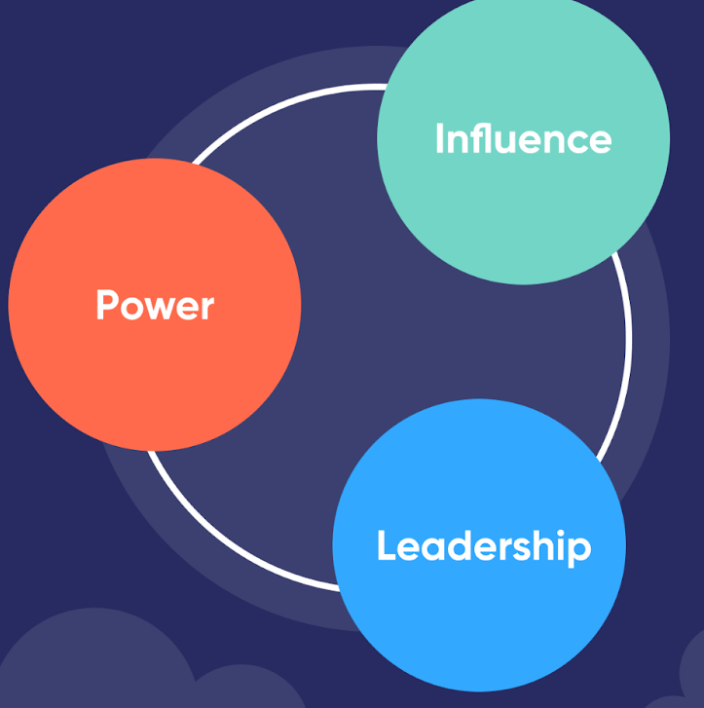

**Power vs. influence**

Powerful leaders have a great capacity to influence others. Their power is based on a combination of their innate leadership qualities and the way others perceive them.

However, having power does not necessarily equate to having influence. The most powerful leaders support and uplift their team members instead of dominating and controlling them. Also known as servant leaders, those who put the needs and development of their employees first have the greatest influence.

**Power and leadership**

The most powerful leaders have clarity and self-discipline. This allows them to lead by example. By modeling disciplined behaviors, they encourage and inspire their team members to do the same. And when employees are self-disciplined, they require less micro-management. This, in turn, increases the leader’s power, creating a virtuous cycle of trust and self-leadership.

Insightfulness is another key aspect of a leader’s power. An insightful leader has the capacity to see the bigger picture and communicate that vision. Their insights give them greater power and influence over their team members.

The greater the impact a leader can have, the more they will be perceived as powerful by their employees. Using your creativity to find solutions, make decisions, and set organizational goals can increase your perceived power among your employees.

Confident leaders also have more power and influence over their subordinates. You can cultivate confidence by acting in line with your values and defending your positions.

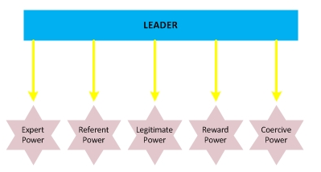

**Expert Power**

Expert power comes from having both deep technical knowledge and extensive experience in your field of expertise. When you’re the expert in your field, people in your company naturally come to you to benefit from your knowledge. Your expertise gives you credibility, and people trust and respect your opinions.

Expert power gives you the ability to influence co-workers across all levels of the organization. This enables you to steer the growth and development of both individual colleagues and the company as a whole. However, a true expert knows they must continue developing their knowledge and skills to maintain credibility.

**Referent power**

According to Nicole Lipkin, author of “What Keeps Leaders Up At Night,” this is the type of power that gives a leader the greatest influence.

Leaders get referent power through qualities that inspire trust and respect in their colleagues. These include honesty and integrity. A person who holds referent power has excellent interpersonal skills and exudes confidence. This makes them natural leaders. They listen to their colleagues and offer help and support.

This type of power is internal rather than external. It is a personal power that cannot be handed to you by someone else. As your referent power grows, so too will your capacity to influence your colleagues.

**Legitimate Power**

This is a type of formal power that you receive when you occupy a certain position in your organization.

Depending on the position, it gives you authority within the company. It also lasts as long as you remain in that role. This type of power is recognized by subordinates. For this reason, it works well in hierarchical organizations such as the military.

Legitimate power is obtained through demonstrating you have the skills required for the role. Because this type of power is given, it can also be taken away. Effective leaders don’t depend solely on legitimate power. Instead, they use it in combination with others.

**Reward Power**

Reward power means having the capacity to offer rewards or benefits in exchange for carrying out a task or achieving a result.

Rewards usually come in the form of raises, benefits, promotions, or public praise. However, this type of power is not always as effective as some leaders think.

It should be relevant and tangible enough to motivate your employees. It should also be something that’s within your power to give and doesn’t depend on your superiors.

This type of power may help achieve results, but it doesn’t necessarily ensure the support or commitment of your employees.

**Coercive Power**

Coercive power is one of the most commonly used in many workplaces, yet it is also the least effective. **In fact, Lipkin advises leaders, please never to use coercive power.**

It involves using threats to force people to do your will. They might not agree with what they have to do, but they do it out of fear of repercussions such as losing their jobs. For example, in many companies, leaders demand constant innovation and new ideas from their employees. Those who don’t measure up face being replaced by someone else.

Although it may work in the short-term, coercive power creates unhappy, disengaged employees and is best avoided. It can also negatively affect employee retention efforts.

**What types of power do effective leaders use the most?**

Effective leaders know how to draw on the different types of power in different situations. This is usually a skill that develops with experience. Bear in mind that certain types of power are only effective in situations that require immediate action or resolution.

For the most part, you will rely on softer types of power to encourage employee commitment to organizational goals and plans. These include legitimate, referent, and expert power.

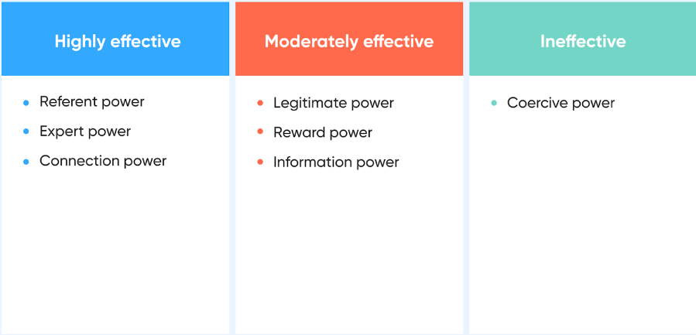

**How to use the 5 types of power?**

It’s important to understand each type of power before looking to apply it. Once you have a good grasp of each one, you can consider ways to apply them at work.

**Understand your goals:** It’s much easier to create a plan when you know what the end goal is. The same can be said for leadership styles and types of power. Before delegating or motivating your team, understand what you want to achieve in doing so.

**Understand your team:** It’s also important to know who you are speaking to and what they value. You can get to know your team better with async check-ins, 1:1 meetings, casual coffee chats, or more structured employee engagement surveys. By familiarizing yourself with your team, you will have a better idea of which power types to use and when.

**Consider your leadership style:** Are you a democratic leader who likes to hear from each individual before making a decision? Or do you take a more top-down approach? Different leadership styles feed into and support various types of power, so try to think of them as a cohesive partnership for great leadership.

**Reflect and revise your approach:** You might have great success the first time you apply a new type of power. But if it falls flat and does not resonate with your team (or your own values), then try another approach. Remaining flexible and being open to feedback will make the process easier.

**Who are all the great positive leaders of the World?**

* Mahatma Gandhi (1869-1948)
* Nelson Mandela (1918-2013)
* Winston Churchill (1874-1965)
* Martin Luther King Jr (1929-1968)
* Abraham Lincoln (1809-1865)
* Mother Teresa (1910-1997)
* Napoleon Bonaparte (1769-1821)
* George Washington (1732- 1799)
* Dalai Lama (1935-present)
* Julias Caesar (100B.C.-44B.C.)
* Franklin D Roosevelt (1882 – 1945)
* Asoka (304 BC – 232 BC)
* Alexander, The Great (356 BC – 323 BC)
* Maharaja Ranjit Singh (1780 – 1839)
* Bill Gates (1955 – Present)

**Who are all the Most Popular Leaders in the World 2022?**

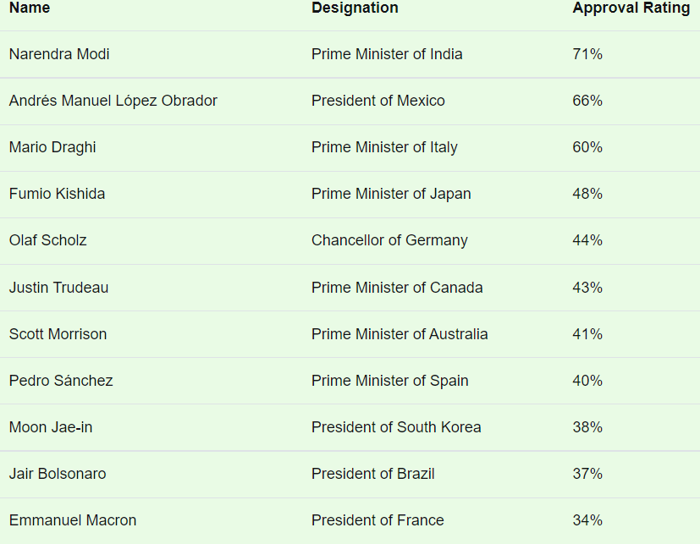

**Leadership Style of Indian Prime Minister - Narendra Modi Ji**

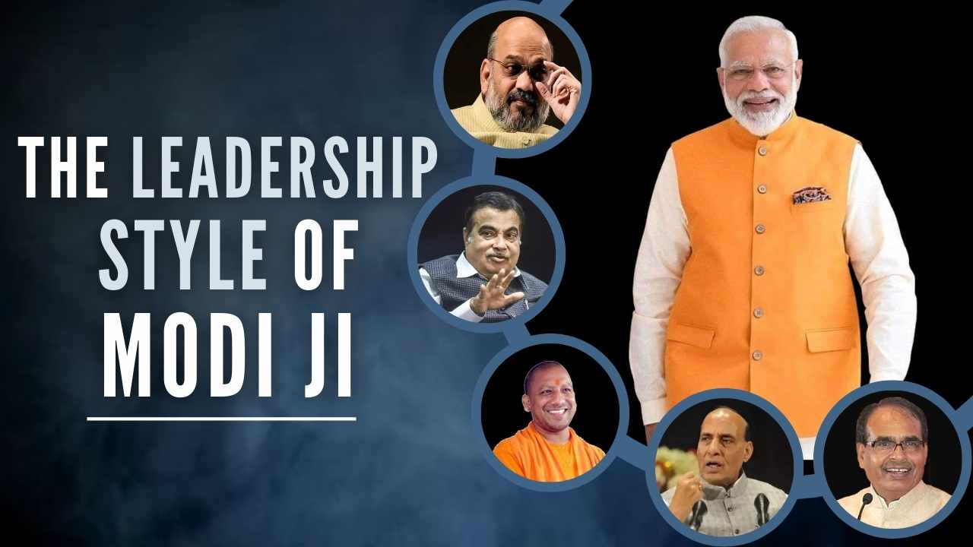

The five leadership qualities that make him an exemplary Indian Prime Minister:

Narendra Modi is a well-known politician in India and the current Prime Minister of India. He has been the chief minister of Gujarat for over two terms, and was also the president of the Gujarat BJP.

Modi is known for his strong leadership qualities, and these qualities have made him a successful politician. Here are some of the leadership qualities that make Narendra Modi a successful leader.

**1. Strong Leadership**

Modi is a powerful and effective leader who knows how to get things done. He has a track record of delivering on key promises, and his ability to lead by example is unmatched.

Under his leadership, India has made significant progress in many areas, including economic growth, job creation, and infrastructure development.

**2. Visionary**

Modi is a visionary who understands the importance of taking risks and forging new paths forward. He has demonstrated great courage and conviction in his efforts to change India for the better, and his innovative ideas have generated widespread excitement and enthusiasm among citizens and experts alike.

**3. Pro-Business**

Modi is committed to promoting economic growth and prosperity for all Indians, regardless of socioeconomic background or location.

He is known for his pragmatic approach to governance, which focuses on solutions that work best for society as a whole rather than sticking to ideological dogma.

**4. Strong Leadership Skills**

Modi is a highly effective leader who inspires trust and confidence among his subordinates. He has a clear vision for India’s future, and his team members are able to trust in his leadership and work diligently under his direction.

**5. Resilience and Determination**

Despite facing many challenges during his time as Prime Minister, Modi has never given up or yielded to pressure.

He has remained steadfast in his beliefs and continued to lead India forward even when the odds seemed insurmountable. This resilience demonstrates strong character traits that are essential for any successful leader.

These five qualities make Modi an exemplary Indian Prime Minister, and make him a valuable asset to any team. He is able to lead with confidence and determination, and his skills as a leader are unmatched.

**World Vision**:

* Narendra Modi is a highly successful leader with many leadership qualities. He has demonstrated an ability to get things done and has a proven track record of success.
* He also possesses the traits of charisma and persuasiveness, which are essential for effective leadership.
* Overall, Modi is a great choice for Prime Minister of India and his policies will likely be successful in driving growth and improving the quality of life for all Indians.

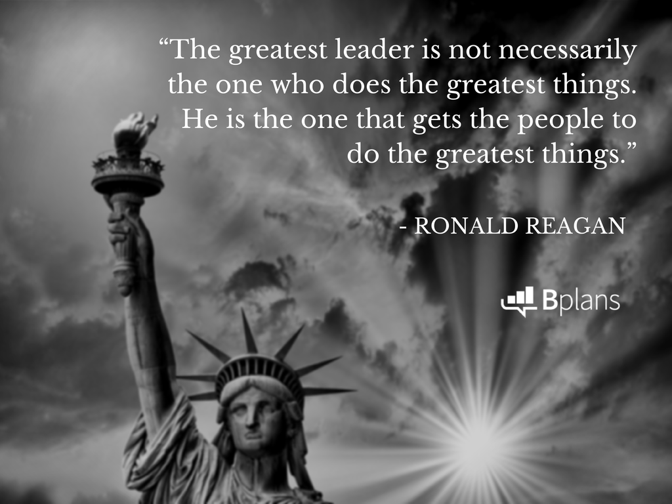

**What is Servant Leadership?**

**Servant Leadership.** The practice of leading through service to the team, by focusing on understanding and addressing the needs and development of team members in order to enable the highest possible team performance.

You must be the change you wish to see in the world. You are the change agent for your organization. According to Robert K Greenleaf. The Servant-leader is servant first… it begins with the natural feeling that one wants to serve, to serve first. The conscious choice brings one to aspire to lead. That person is sharply different from one who is leader first, perhaps because of the need to assuage an unusual power drive or to acquire material possessions. The leader-first and servant-first are two extreme types. Between them there are shadings and blends that are part of the infinite variety of human nature.



On character and Servant Leadership

* Listening & Healing
* Empathy
* Awareness
* Persuasion
* Conceptualization
* Foresight
* Stewardship
* Commitment to the growth of people
* Building community

The primary duties are:-

* Shield the organization | team from interruptions
* Remove any obstacles for progress
* Communicate organization | team vision
* Carry knowledge with high performance resources (Food & Water) towards victory

**What is an Influential Leadership?**

An influential leadership is someone people look up to, respect and trust to guide them towards their desired results. Instead of coercing or forcing their team, the influential leader empowers their people and leads by example.

To prepare yourself to wield a blended approach throughout your career to influence, Clapasson suggests you do these five things: -

1. Know the people you want to influence. Spend time getting to know your team and showing them that they can trust you and work with you. As Stephen Covey wrote, “Seek first to understand, then to be understood.”

2. Aim to be liked and respected by those you seek to influence. People want to be led by people they like, but that does not mean becoming everyone’s ‘best buddy.’ Instead, be a concerned, engaged leader who is connected to both the vision of the organization and wellbeing of its people.

3. Commit to the people you want to influence. If you are not committed to your team, why should they have any reason to follow you? Find ways to show others that you are committed to them on a group level and on an individual level.

4. Engender mutual commitment to help influence thrive. Commitment works both ways. In order to influence people, they team need to be committed to you, too. Have conversations with your team to discover what they’re truly committed to and help make sure everyone is on the same page.

5. Be strong, focused, and a good example to those you want to influence. When you set a good example, people will naturally want to follow you. Position yourself as a leader with a strong goal and the ability to meet that goal.

**What are the 9 different influence approaches of Leadership?**

There are 9 organizational power tactics. These tactics are ways in which individuals translate power bases into specific actions.

The 9 influence tactics are legitimacy, rational persuasion, inspirational appeals, consultation, exchange, personal appeals, ingratiation, pressure and coalitions.

* **Rational persuasion** A tactic that is used to try and convince someone with a valid reason, rational logic, or realistic facts.
* **Inspirational appeals** A tactic that builds enthusiasm by appealing to emotions, ideas and/or values.
* **Consultation** A tactic that focuses on getting others to participate in the planning process, making decisions, and encourage changes.
* **Ingratiation** A tactic that emphasizes on getting someone in a good mood prior to making a request. It includes being friendly, helpful, and using praise or flattery.
* **Personal appeals** A tactic that refers to friendship and loyalty while making a request.
* **Exchange** A tactic that suggests that making express or implied promises and trading favors.
* **Coalition tactics** Refers to a tactic that prescribes getting others to support your effort to persuade someone.
* **Pressure** A tactic that focuses on demanding compliance or using intimidation or threats.
* **Legitimating tactics** This tactic suggests that basing a request on one’s authority or right, organizational rules or policies, or express or implied support from superiors, is a best.

**What is leadership empowerment?**

Empowering leadership is a promising strategy for leaders to positively shape employee attitudes and behaviors, including cynicism and time theft (Huy 2002; Oreg & Berson 2011). Empowering leaders share power with their subordinates, giving them decision-making authority. They also express confidence in employees’ abilities to perform their jobs autonomously (Spreitzer 1995).

Empowerment includes four leader behaviors: highlighting the significance of employee work, allowing employee participation in decision-making, emphasizing employee strengths, and removing bureaucratic constraints (Ahearne et al. 2005; Kirkman & Rosen 1999; Leach, Wall, & Jackson 2003). In turn, employees feel psychologically empowered if they perceive meaning, competence, autonomy, and impact in their work (Conger & Kanungo 1988; Kirkman & Rosen 1999; Spreitzer 1995).

Based on prior research, we predict empowering leadership is associated with cynicism directly and indirectly via individual psychological empowerment. That is, we expect empowering leader behaviors to motivate employees to want to “repay” those benefits, increasing employee motivation and trust in the leader, as well as employee perception of their own state of psychological empowerment. In turn, we expect cynicism is less likely to develop among psychologically empowered employees, because they adjust their attitudes and workplace behaviors to “pay for” the positive benefits received. The result of empowering leaders should be less employee cynicism leading to higher employee productivity.

# 5. Team Leadership

**What is Team Leadership?**

Team leadership is when a person gets people to work together so they can achieve a specific desired outcome. Team leaders use a variety of leadership skills such as vision and motivation to drive people to perform at their highest level. They also teach the group how to rely on one another’s strengths so they can accomplish goals more efficiently and effectively.

**Team Leadership Skills**

**1. Communication**

A leader who can’t communicate isn’t much of a leader at all. Communication skills come in many forms, such as nonverbal, written, and public speaking. Many established business leaders say that public speaking is an essential skill everyone should develop. Warren Buffett once told Columbia University business students that simply learning communication skills like public speaking “can improve your value by 50 percent.” Even if public speaking isn’t your forte, casual conversations with team members can give you the opportunity to show your appreciation of their work and inspire them with newfound confidence. Additionally, learning more about how to balance introversion and extroversion by becoming an ambivert can drastically improve your communication abilities.

**2. Constant Learning**

With so much changing in the business world, an essential skill for leadership and management is constant learning. Leaders need to have an inquisitive mind eager to consume more information. Search for books and articles to read. Find topics that fascinate you. These topics don’t have to be immediately related to the company you work for, but make sure to include reading material that will help expand upon and improve your skillset.

**3. Delegation**

A team leader can’t do it all. You’ll need to learn the fine art of delegation to achieve your team’s goals. In the immortal words of Henry Ford, “Nothing is particularly hard if you divide it into small jobs.” Delegation saves time and keeps stress levels low for the entire team. It also shows your confidence in your team members as you trust them to handle important tasks and responsibilities.

**4. Listening**

Effective team leaders need to know what their team members are thinking, and the best way to do that comes from listening. Take the time to listen to understand people’s complaints and concerns. By listening, you can pinpoint where problems might happen, or obstacles could spring up. You’ll also have an easier time addressing concerns before they turn into full-fledged disasters. Team members will appreciate knowing that they have a leader who cares enough to hear them out.

**5. Goal Setting**

Poet Bill Copeland once said, “The trouble with not having a goal is that you can spend your life running up and down the field and never scoring.” Teams can work hard every day, but if the team leader fails to set a goal properly, they risk having all that work go to waste. Create a clear vision for your team. Make sure they all understand what they’re working toward. Outline the steps needed to reach it. Once team members see the big picture, they’ll have a better grasp of the context of their work.

**6. Trustworthiness**

No one wants to work for an employer they don’t trust, but unfortunately, it happens. Research from EY found that less than half of workers worldwide place “a great deal of trust” in their leaders. Executives, directors, and managers must earn the trust of their team members. Many of the above skills, such as communication and listening, go a long way toward establishing a high level of trust. Be upfront and transparent with team members. Don’t keep them in the dark on important details involving company strategy. As long as workers feel like their supervisor treats them with respect, integrity, and fairness, employees will trust their leaders to guide them where they need to go.

**7. Positivity**

People don’t like to listen to doom and gloom all day. They want to hear good news and positivity, especially when it relates to their jobs. Team leaders need to show this positive attitude to motivate and inspire their teams. Equally important is the need to show this positivity each day. A positive demeanor can quickly spread to the rest of the team. When everyone has a good attitude, productivity will increase, and people will feel more fulfilled and happier at work.

**8. Self-Accountability**

Just like team leaders must set a good example, they also need to hold themselves accountable. Team leaders who shift the blame to their team members will only lead to discord and conflict among their teams. Take full responsibility if things go wrong. Show that you’re willing to learn and correct past mistakes. Team members will see this and practice self-accountability as well. If everyone does this, they’ll lift each other to a higher level of performance.

**9. Sharing Vision**

Many team leaders find themselves getting pressure from above as well as below. They have their own bosses to answer to, so they have to show the willingness to be followers as well as leaders. Part of this responsibility includes understanding the vision for the company and getting others excited for it too. Understanding vision also includes understanding the role they and their team play in the big picture. To do this, team leaders will need to work closely with their bosses and their teams to catch the vision and impart its importance to others.

# 6. Organizational Leadership

**What is Organizational Leadership?**

Organizational leadership is the ability to lead groups of individuals toward fulfilling an organization's mission.



**Building Tanjore Temple with architecture is a good example for Org. leadership**

It encompasses the following skills:

* Understanding an organization's mission, in alignment with one's strengths.
* Creating a strategic plan in line with that mission.
* Implementing goals and holding teams accountable for accomplishing those goals within an established timeline, and in alignment with the strategic plan.
* Foreseeing possible challenges in the road ahead.
* Innovating to meet those challenges.
* Pivoting effectively as circumstances change.
* Remaining calm amidst uncertainty.
* Communicating effectively.
* Inspiring groups of individuals to do their best and work toward a unified purpose.
* Addressing the concerns of internal stakeholders and the community at large.
* Doing all of the above, with an eye on inclusivity, integrity, and authenticity.

**Organizational leadership vs. traditional management**

Organizational leadership encompasses a broader scope of responsibility than traditional management. Organizational leadership communicates the mission and vision, establishes the strategic plan, and inspires individuals to put forth their talents to fulfill the goals aligned with the strategic plan and, ultimately, the leader’s vision.

Traditional management fulfills only part of that overall vision. The manager’s role has been typically to communicate leadership’s direction, set expectations, assign tasks, problem solve, and complete the goals assigned to that particular group.

**Why is organizational leadership important?**

Traditional management has been downplayed in recent years as “maintaining” the status quo. With innovation and disruption happening at record speed, management doing things as they’ve always been done is not enough. Organizational leadership is needed at every level to consider how current practices can be further improved or changed to meet future needs.

**Organizational leadership is important because it:**

Motivates team members. Team members respond in kind to the leader. They will be motivated to mirror the growth mindset for their teams and themselves and consider how they can personally contribute to the forward momentum of the organization as a whole.

Allows for a problem-solving and decision-making mindset. In a psychologically safe atmosphere where people are not afraid to speak up, great ideas can emerge. When a leader entrusts the individuals hired into their roles to develop solutions and make decisions, exponential growth is possible.

Promotes communication, ethics, inclusion, and respect. The highly emotionally intelligent organizational leader communicates in all ways that all employee's contributions are respected, as every role is vital to the organization's forward movement as a whole. The leader shares the organization's values and models the communication, ethics, inclusion, and respect expected of each individual.

Allows organizational leaders to remain goal-oriented. With individuals empowered to fulfill their roles and develop innovative solutions, the organizational leader may focus on the larger picture: moving the mission forward with an eye on navigating the challenges ahead.

# 7. Leadership Character & Ethics

**What are the Leadership Character?**

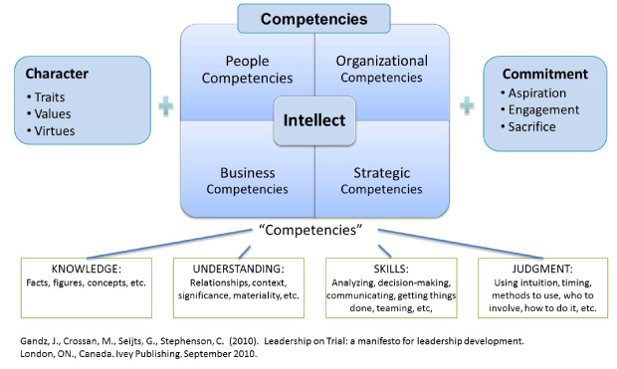

Leadership characters are personality traits, values and virtues.

**Traits**

Traits are defined as habitual patterns of thought, behavior and emotion that are considered to be relatively stable in individuals across situations and over time. Traits are not fixed. For example, introverts may be able to learn how to behave in a less introverted way, while extroverts may learn how to control and moderate their extroverted behaviors when situations require it.

There are, literally, hundreds of personality traits from A (ambition) to Z (zealousness) that have been described in the psychology literature. However, through statistical techniques such as factor analysis, five broad domains, or dimensions, of personality have emerged, and are now widely used in various forms in employee selection and assessment.

The “Big-Five” traits are:

* Conscientiousness
* Openness to experience
* Extroversion
* Agreeableness, and
* Neuroticism

These five traits feature prominently in tests or inventories and they have come to be known as the FFM, or the five-factor model, a robust model of personality. Although the Big Five dominate the personality literature, there are various other traits that warrant consideration and measurement, such as self-confidence, ambition, perfectionism, dominance, rigidity, persistence and impulsivity.

Some personality traits can be inherited. For example, studies have shown that identical twins that have the same genes show more traits that are similar than non-identical twins. Traits, of course, also evolve through life experiences and deliberate developmental exercises such as coaching.

**Values**

Values are beliefs that people have about what is important or worthwhile to them. Values influence behavior because people seek more of what they value. If they can get more net value by behaving in certain ways, they will. Values therefore can be seen as the guideposts for behavior. Some people value their autonomy very highly, some value social interaction, some value the opportunity to be creative, some value work-life balance, and so on. Values may change with life stages and according to the extent to which a particular value has already been realized. For example, a new graduate strapped by student loans may value a high starting salary. That same person 30 years later may well pass up a high-paying job for one that paid less, but allowed him to live close to his grandchildren or somewhere with greater access to recreational activities.

An individual’s values are in large part derived from the social environment in which he or she lives. In Western democracies, life, liberty and the pursuit of happiness are some of the things we value. Other societies value order, harmony, non-violence and equality. If we are brought up with strong religious traditions, some of us develop values based on the teachings of those religions. Similarly, our value frameworks may be influenced by our home life, fraternal societies we join, experiences obtaining an education, the companies we work for, our friends, and many other social influences.

An important sub-set of values consists of those with ethical or social dimensions, such as honesty, integrity, compassion, fairness, charity and social responsibility. Such moral values may be strongly or weakly held and influence behavior accordingly.

Values may be espoused though they may not necessarily be manifested. For example, it’s not unusual for people to experience value conflicts in certain situations. When loyalty conflicts with honesty, when fairness conflicts with pragmatism, or when social responsibility conflicts with obligation to shareholders, people become conflicted. And when their actions are inconsistent with their values, they either experience guilt, anger and embarrassment. People try to minimize such cognitive dissonance by rationalizing or even denying their behavior, discounting the consequences of it or simply blaming others.

**Virtues**

From the time of the ancient Greeks, philosophers have defined certain clusters of traits, values and behaviors as “good,” and referred to them as virtues. Virtues are like behavioral habits – something that is exhibited fairly consistently. For example, Aristotle wrote that: “We are what we repeatedly do. Excellence, then, is not an act, but a habit.”

Aristotle identified and defined twelve virtues: Courage, Temperance, Generosity, Magnificence, Magnanimity, Right ambition, Good temper, Friendliness, Truthfulness, Wit, and Justice. The twelfth virtue is Practical Wisdom, which is necessary to live the “good life” and thus achieve happiness or well being.

Consider the virtue of Courage. Traits such as openness to experience, self-confidence and persistence contribute to individuals acting in distinctive ways – for example, putting themselves on the line and acting in a courageous fashion. Having values such as integrity, treating individuals with respect and achievement predisposes individuals to demonstrate courageous behavior. Furthermore, a person with integrity tends to act in a different way than a person who lacks integrity, even if both individuals find themselves in the same situation. Then there is a set of actual behaviors that individuals engage in – on a fairly consistent basis (meaning across situations and over time) – and that friends, colleagues and observers characterize or describe as courageous. These behaviors may have become societal expectations.

The ten virtues of a cross-enterprise leader: -

We propose that cross-enterprise leaders who focus on the long-term performance of their organizations must demonstrate ten virtues.

* Humility is essential to learning and becoming a better leader
* Integrity is essential to building trust and encouraging others to collaborate
* Collaboration enables teamwork
* Justice yields decisions that are accepted as legitimate and reasonable by others
* Courage helps leaders make difficult decisions and challenge the decisions or actions of others
* Temperance ensures that leaders take reasonable risks
* Accountability ensures that leaders own and commit to the decisions they make and encourages the same in others
* Humanity builds empathy and understanding of others
* Transcendence equips the leader with a sense of optimism and purpose
* Judgment allows leaders to balance and integrate these virtues in ways that serve the needs of multiple stakeholders in and outside their organizations.

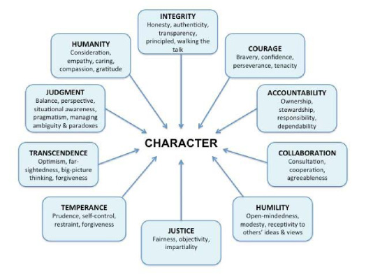

**Ten Leadership Virtues**

But if you consider what may happen when leaders lack these virtues, the effects become more obvious (see Table below).

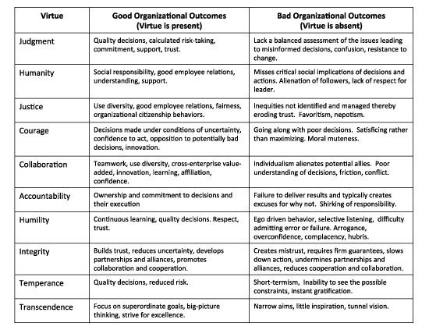

Without Judgment leaders make flawed decisions, especially when they must act quickly in ambiguous situations, namely when faced with the many paradoxes that confront all leaders from time to time.

Without Humanity leaders are unable to relate to others, see situations from their followers’ perspectives or take into account the impact of their decisions on others. Without humanity leaders will not act in socially responsible ways – they will alienate people.

Without a Sense of Justice leaders are unable to understand the issues of social inequality and the challenges associated with fairness. Such leaders act in unfair ways and reap negative consequences in the form of poor employee relations or reactions by customers, governments and regulators. People will rebel and find ways to undermine the leader.

Without Courage leaders will not stand up to poor decisions made by others and will lack the perseverance and tenacity required to work through difficult issues. They will also back down in the face of adversity and choose the easy route. But in doing so they only postpone the inevitable.

Without Collaboration leaders will fail to achieve those worthwhile goals that require more than individual effort and skills. They don’t use the diversity of others’ knowledge, experience, perceptions, judgments and skills to make better decisions and to execute them better. Friction among different stakeholders results and relations deteriorate.

Without Accountability leaders don’t commit to, or own, the decisions they make, and cannot get others to do so. They blame others for poor outcomes and in doing so create a culture of fear and disengagement. People stop caring, with potentially disastrous consequences.

Without Humility leaders cannot be open-minded, and solicit and consider the views of others. They can’t learn from others, they can’t reflect critically on their failures and become better leaders as a result of those reflections. They become caricatures of themselves. Isolation results.

Without Integrity leaders cannot build good relationships with followers, with their organizational superiors, with allies or partners. Every promise has to be guaranteed and the resulting mistrust slows down decisions and actions.

Without Temperance leaders take uncalculated risks, rush to judgment, fail to gather relevant facts, have no sense of proportion, and make frequent and damaging changes or even reverse important decisions. Their credibility suffers.

Without Transcendence leaders’ goals become narrow and they fail to elevate discussions to higher-order goals. They don’t see the bigger picture and hence their decisions may reflect opportunism only. They don’t think outside the box or encourage others to do so.

**What is Ethics?**

Ethics is comprised of values, beliefs, and practices of an individual, group, or society that are perceived as morally correct and acceptable to everyone in a particular environment. Theories relevant to ethical behavior center around three distinct approaches to understanding the ethical consequences of decision making and differ on two key dimensions concern for self-interests and concern for other interests.



**What is Ethical Leadership?**

Ethical leadership means both acting ethically and setting the standard for others to do so as well. Leaders have an opportunity to inspire others not only to do the right thing but also to consider the kind of people they want to be.

Some activities leaders engage in to set standards that encourage ethical behavior include:

* Creating clear boundaries
* Guiding policy development
* Asking the right questions
* Reframing issues to bring forward ethical considerations
* Creating systems designed to motivate ethical action
* Taking responsibility for creating ethical cultures in organizations

**What are the best practices of Ethical Leadership?**

An ethical and responsible leader must have organizational support and shared, clearly aligned values for the leader to effectively demonstrate those values for the leader to effectively demonstrate those values for the leader to effectively demonstrate those values through their visible behaviors and actions for followers to believe in support, and emulate. An array of ethical best practices is highlighted below, and many of them will be familiar because they are also part of transformational leadership.

**Leading by Example**

* Acting as a role model, accessible for followers to align with adopt in their behaviors
* Conducting themselves professionally in all situations
* Demonstrating humility, not allowing ego to influence decisions and actions; selflessness
* Holding oneself accountable for the performance outcomes and results on behalf of the group or organization
* Fostering trust and loyalty by being accessible to followers and dependable by keeping promises

**Demonstrating Integrity**

* Treating everyone with respect, comparison and dignity, aware of followers needs, interests and concerns
* Refraining from exploiting, manipulating, or taking advantage of any followers or group members, avoiding unethical influence tactics such as guilt, peer pressure, ingratiation, harassment, and coercion
* Making decisions that followers perceive as just, correct and morally sound
* Integrating shared values into decisions made and actions taken
* Integrating shared values into decisions made and actions taken
* Maintaining resilience through challengers without resorting to easy or unethical alternatives
* Acting with generosity and a spirit of giving to others

**Diplomacy and Civic Relations**

* Communicating with honesty and straight forwardness
* Demonstrating transparency with no hidden agendas
* Having empathy for other seeing a situation through the lens of others and understanding their needs and point of view
* Maintaining objectivity and unbiased perspectives
* Supporting inclusion in which no one is left out or excluded within the group
* Handling conflicts through fair and relational resolution approaches

**Focus**

* Maintaining appropriate attention to short and long-term goals along with needs that arise unpredictability
* Demonstrating self-control and discipline in completing tasks and making progress on meeting objectives
* Avoiding spreading oneself and the group too thein which may lead to compromising behaviors
* Remaining firm on values and position, not easily persuaded or influenced to shift towards someone else agenda that deviates from the mission to serve the greater food

With these behaviors and practices are all integrated, they comprise a true depiction of ethical leadership, comprehensively organized within five core principles of ethical leadership described below.

Ethical leaders are an important asset to any business, in fact, all organizations should look to employ ethical leaders within their company.

Because of their traits, ethical leaders can have a positive impact on the workplace. They can improve the wellbeing of employees, benefit the bottom line and boost the overall moral. This ultimately results in employees remaining loyal, a lower staff turnover and a higher team performance.

Ethical leaders have five principles: respect, service, honesty, justice and community. Let’s have a look at these in more detail.

**Respect**

Ethical leaders really listen to their colleagues. They will be empathetic and tolerant of others’ opinions even if their views do not align. Employees will be encouraged to realize their own purpose and values which in turn promotes ethical qualities to spread throughout the business.

**Service**

This is the primary building block of a moral leader as they will always prioritise the interest of others. Within businesses this is shown through mentorship, performance plans and team building.

**Honesty**

Being completely open and honest is something an ethical leader will always do; they are people of complete integrity. For example, they will not promise something if it cannot be delivered and will take accountability if things go wrong.

**Justice**

An ethical leader will apply the same set of rules to everyone, ensuring all are treated equally and given equal opportunities. Fairness is at the core of this and plays a big part in their decision-making processes. If someone requires different treatment for special circumstances then the reasons for this will be clear, reasonable and morally right.

**Community**

All leaders have goals that they will work towards, ethical leaders work towards these goals while also taking into account their own and their employee’s purposes, ensuring the goals are suitable for all. Ethical leaders will also take into account the wider community and society, reaching out to organizations to achieve a mutual goal with a positive impact.

# 8. Leadership Management Style

**What Are the different Types of Leadership Styles?**

* All leaders have a unique style that sets them apart from others. Hence, these different types of leadership styles will help you decide which type of leader you want to achieve.

**Autocratic leadership**

* A leader who has complete control over his team is called an autocratic leader. They never bend their beliefs and rules for anyone. Additionally, their team has no say in the business decisions. Moreover, the team is expected to follow the path directed by the leader.
* This archaic style of leadership has very few takers because it discourages change. And modern leaders are changing the definition of leadership and redefining what leadership is with their path-breaking decisions.

**Laissez-Faire leadership**

* Laissez-Faire is derived from a French word that means ‘allow to do’. “The practice of non-interference in the affairs of others, especially with reference to individual conduct or freedom of action,’ defines dictionary.com. In this type of leadership, team members have the freedom to perform their job according to their will. They are given the freedom to bring in their perspective and intelligence in performing business functions. If you take up a leadership course, you’d get to learn about it in detail.

**Democratic leadership**

* In this type of leadership, team members and leaders equally contribute to actualizing business goals. Furthermore, they work together and motivate each other to achieve their personal goals too. This type of leadership leads to a positive working environment.

**Bureaucratic leadership**

* In this type of leadership, leaders strictly adhere to organizational rules and policies. They make sure that their team members do the same. Bureaucratic leaders are often organized and self-motivated.

# 9. Leadership Communication

**Why Communication is important in Leadership?**

A leader is someone who inspires positive, incremental change by empowering those around them to work toward common objectives. A leader’s most powerful tool for doing so is communication.

Effective communication is vital to gain trust, align efforts in the pursuit of goals, and inspire positive change. When communication is lacking, important information can be misinterpreted, causing relationships to suffer and, ultimately, creating barriers that hinder progress.

If you’re interested in enhancing your leadership capabilities, here are eight communication skills you need to be more effective in your role.

**Essential Communication Skills for Leaders**

**1. Ability to Adapt Your Communication Style**

Different communication styles are the most frequently cited cause of poor communication, according to the Economist Intelligence Unit (pdf), and can lead to more significant issues, such as unclear priorities and increased stress.

It’s essential to identify your leadership style, so that you can better understand how you’re interacting with, and perceived by, employees across the organization. For example, if you’re an authoritative leader, you likely have a clear vision for achieving success and align your team accordingly. While an effective approach for some, it might fall flat for others who seek more autonomy in their role.

All employee’s motivations are different, so knowing how to tailor your communication is essential to influencing others and reaching organizational goals.

**2. Active Listening**

Effective leaders know when they need to talk and, more importantly, when they need to listen. Show that you care by asking for employees’ opinions, ideas, and feedback. And when they do share, actively engage in the conversation—pose questions, invite them to elaborate, and take notes.

It’s important to stay in the moment and avoid interrupting. Keep your focus on the employee and what it is they’re saying. To achieve that, you also need to eliminate any distractions, including constant pings on your cell phone or checking incoming emails.

**3. Transparency**

In a survey by the American Management Association, more than a third of senior managers, executives, and employees said they “hardly ever” know what’s going on in their organizations. Transparency can go a long way in breaking down that communication barrier.

By speaking openly about the company’s goals, opportunities, and challenges, leaders can build trust amongst their team and foster an environment where employees feel empowered to share their ideas and collaborate. Just acknowledging mistakes can encourage experimentation and create a safe space for active problem-solving.

Every individual should understand the role they play in the company’s success. The more transparent leaders are, the easier it is for employees to make that connection.

**4. Clarity**

When communicating with employees, speak in specifics. Define the desired result of a project or strategic initiative and be clear about what you want to see achieved by the end of each milestone. If goals aren’t being met, try simplifying your message further or ask how you can provide additional clarity or help.

The clearer you are, the less confusion there will be around priorities. Employees will know what they’re working toward and feel more engaged in the process.

**5. Ability to Ask Open-Ended Questions**

If you want to understand employees’ motivations, thoughts, and goals better, practice asking open-ended questions. Jennifer Currence, president of consulting firm The Currence Group, said to the Society of Human Resource Management to use the acronym TED, which stands for:

“Tell me more.”

“Explain what you mean.”

“Define that term or concept for me.”

By leveraging those phrases when speaking with your team, you can elicit more thoughtful, thorough responses and ensure you also have clarity around what they need from you to succeed.

**6. Empathy**

There’s a reason empathy has been ranked the top leadership skill needed for success. The better you get at acknowledging and understanding employees’ feelings and experiences, the more heard and valued they’ll feel.

In a recent survey (pdf), 96 percent of respondents said it was important for their employers to demonstrate empathy, yet 92 percent claimed it remains undervalued. If you want to improve your communication and build a stronger, more productive culture, practice responding with empathy.

**7. Open Body Language**

Communication isn’t just what you say; it’s how you carry yourself. Ninety-three percent of communication’s impact comes from nonverbal cues, according to executive coach Darlene Price.

To ensure you’re conveying the right message, focus on your body language. If you’re trying to inspire someone, talking with clenched fists and a furrowed brow isn’t going to send the right message. Instead, make eye contact to establish interest and rapport and flash a genuine smile to convey warmth and trust.

**8. Receiving and Implementing Feedback**

Asking for feedback from your team can not only help you grow as a leader, but build trust among your colleagues. It’s critical, though, that you don’t just listen to the feedback. You also need to act on it.

If you continue to receive feedback from your team, but don’t implement any changes, they’re going to lose faith in your ability to follow through. It’s likely there will be comments you can’t immediately act on—be transparent about that. By letting your employees know they were heard and then apprising them of any progress you can, or do, make, they’ll feel as though you value their perspective and are serious about improving.

# 10. Leadership Habits

**What are the good habits of highly effective leadership?**

Stephen R. Covey formulated the good habits of highly effective Leadership

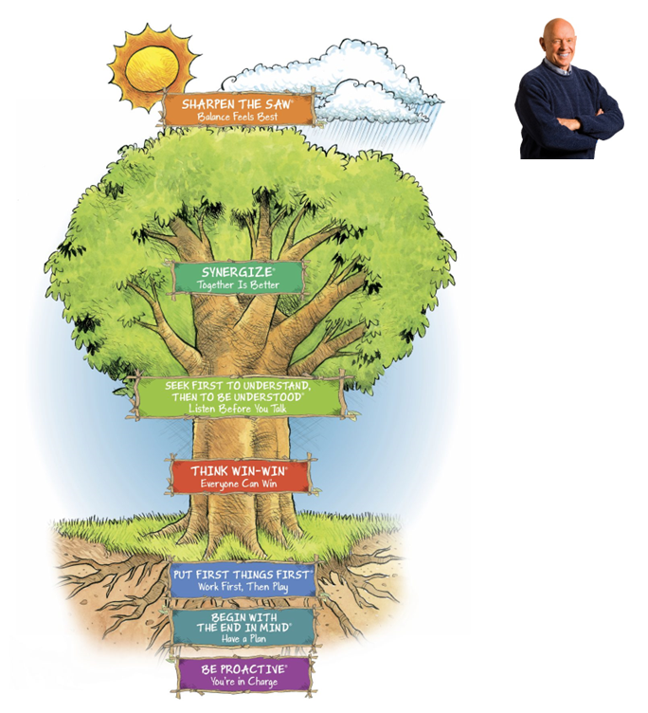

**Habit 1: Be Proactive**, is about taking responsibility for one’s own life. Proactive people don’t blame parents, circumstances, or conditions for their behavior. Instead, they choose to focus on areas of life that lie within their circle of influence.

**Habit 2: Begin with the End in Mind**, reconnects individuals with passion and purpose. By outlining a personal mission statement, a plan for achieving greatness can then be established.

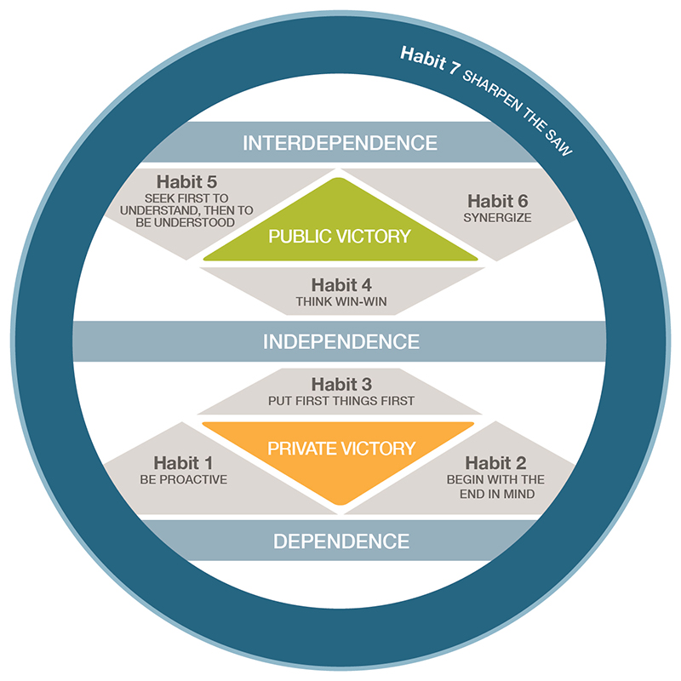

**Habit 3: Put First Things First is about time management**. The Time Matrix® provides a model for identifying and prioritizing tasks based on urgency and importance. Truly effective people ensure the most meaningful tasks related to their personal mission statement are accounted for in weekly and daily planning.

**Habit 4: Think Win-Win**, people work effectively and efficiently with others to achieve optimal results. Society fosters competitive and selfish behaviors that produce win-lose or even lose-lose outcomes. A win-win mentality is a balancing act between courage and consideration that ensures true collaboration takes place in all conflicts.

**Habit 5: Seek First to Understand, Then to Be Understood**

Unknowingly, in conversation we filter what we hear through our own life experiences and frame of reference. Before a person finishes what they are saying, we’ve already formulated a response. Habit 5: Seek First to Understand, Then to Be Understood teaches the art of sincere, reflective listening.

**Habit 6: Synergize**

Synergize is the habit of creative cooperation and can only be achieved by valuing the diverse paradigms and opinions of others. In a synergistic environment, true collaboration takes place because the whole is always greater than the sum of its parts.

**Habit 7: Sharpen the Saw**

Habit 7: Sharpen the Saw challenges a person to seek continuous improvement and renewal. Overcoming burnout can be achieved by taking time for oneself through physical, social/emotional, mental, and spiritual renewal. Habit 7 is revitalizing and helps establish greater capacity for self-improvement.

**What are the good habits of highly in-effective leadership?**

Stephen R. Covey formulated the good habits of highly in-effective Leadership.

* Habit 1: React
* Habit 2: Begin with Squat in Mind
* Habit 3: Put First Things Last
* Habit 4: Think Win-Lose
* Habit 5: Seek First to talk, then pretend to Listen
* Habit 6: Be an island
* Habit 7: Burn Yourself Out

# 11. Leadership Responsibilities

**What are responsibilities of Leadership or CEO ?**

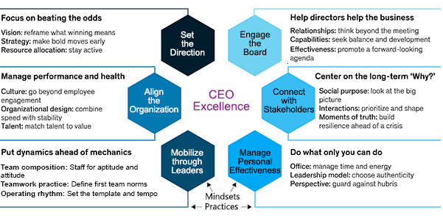

**1. Setting the Direction**

Rather than hedging their bets, the best CEOs are bold. “They’re less a taker of their fate and more a shaper—constantly looking for and acting on opportunities that bend the curve of history.”

**Vision:** They reframe what success means. “The best CEOs often dig back into a company’s history to find out what originally made it successful and then take that central idea and expand it in ways that open up new opportunities.” They add, “what matters to them is to have a clear and simply articulated North Star for the company that redefines success, influences decisions, and inspires people to act in desired ways.”

**Strategy:** Move early and often. “Excellent CEOs are always looking to the next S-curve while ensuring the current one is delivered on.”

**Resource Allocation:** Budgets are not based on last year’s budget. Resources are zero-based and then solved for the whole. “No investment is taken as a given—every investment is scrutinized, alternatives explored, and approval justified by how it helps deliver against the company’s strategy and vision.”

**2. Aligning the Organization**

Once the direction is set, execution is not inevitable. The problem is more than intellectual. It is an emotional one. “You have to fix both sides as the CEO: The easy part is technical; the difficult part is people.”

**Culture:** Align the culture: reshape the work environment, make it personal, make it meaningful, and measure what matters. CEO must embody the change.

**Organizational Design:** “When a CEO sees an organization tilted one way, there’s a temptation to tilt the opposite way—and, like the pendulum of a clock, the swing back and forth between the two polarities is perpetuated. The best CEOs rarely make radical swings from one extreme to the other.”

**Talent Management:** “Your people decisions are really where all your leverage is,” says GE CEO Larry Culp. You must clearly define high-value roles, look for the left tackle positions that protect and enable value to be created, find the unusual suspects, and actively build the bench.

**3. Mobilizing Through Leaders**

The best CEOs and less concerned about what their leaders do together and more concerned about how their leaders work together. “They obsess with solving for the team’s psychology and let the mechanics of coordination and execution follow.”

**Team Composition:** “A group of high performers only become truly high performing if its members are complementary and connected to one another and not simply working side by side.” The best CEOs staff the team with an eye to aptitude and attitude, act fast but fairly regarding those who don’t belong, stay connected while keeping their distance, and build a leadership coalition beyond their immediate team.

**Teamwork Effectiveness:** Those on the top team have a responsibility to the organization over their own units. “I’m on the team so I can represent the company to my function or business.”

**Operating Rhythm:** “When a CEO creates a clear and effective operating rhythm, every member of the top team can sync the rhythm of their specific area with that of the company as a whole.”

As CEO, you have a 30,000-foot view of the organization. You need to make sure your team members have the advantage of that perspective. “If the CEO is not making the gears mesh together, dysfunctions quickly become hardwired.” From Microsoft’s Satya Nadella:

People say the job is lonely. I realized that it’s an information asymmetry problem. Nobody who works for you sees what you see. And nobody you work for sees what you see. That’s the fundamental problem of a CEO, which is you see it all, and nobody else around you see it, so you can get very frustrated.

**4. Engaging the Board**

“The best CEOs help the board chair run the board so that the directors can help the CEO run the business.”

**Board Relationships:** The best CEOs build and maintain trust by choosing radical transparency, building a strong relationship with the board chair, reaching out to individual directors, and exposing the board to management. “Trust is not about charisma or friendship. Trust is based on delivery,” says David Thodey CEO of Telstra.

**Board Capabilities:** Be clear about the role the board should play and make sure they understand the business. Encourage the chair to evaluate board performance.

**Board Meetings:** Focus on the future. Serve on a board yourself to get a perspective on what it is to be a board member. Never get involved in board functions.

**5. Connecting with Stakeholders**

“Research shows that a company’s relationships with external stakeholders can influence as much as 30 percent of corporate earnings.”

**Social Purpose:** Be sure your organization has a powerful reason for why they exist. We live in a time where stakeholders want to hear the CEO or organization take a stand on various social issues. “The best CEOs don’t confuse their personal passions for their company’s principles.”

**Stakeholder Interaction:** Getting it right is not always easy, but the best CEOs share these commonalities: they contain the time spent Outside, they understand the other party’s why, they gather as many good ideas as possible from the interactions, and they maintain a single narrative across all stakeholders. Former Best Buy CEO Hubert Joly explains:

The key with any stakeholder is to get the “say-do” ratio right: the ratio between what we say we were going to do and what we actually did. That’s how you get credibility. And if you’re doing what you are saying you will do, they’ll actually want to see less of you. They’ll want you to be spending your time working on the business and delivering on your commitments.

**Moments of Truth:** Have a crisis playbook that you can tailor to each situation. When a crisis hits, maintain a long-term perspective to keep driving the business forward. Ahold Delhaize’s CEO Dick Boer says there are three lessons for CEOs when dealing with a crisis:

First, do not chair or lead your crisis team. Let them report out to you. This gives you the space and time to oversee all the elements of the business, not only the crisis. Second, show confidence in your organization—show that you’re in control, that you know what you’re doing, and that you’ll take care of your people and your customers. Third, think of what’s next even when the storm is still around you, because there’ll be opportunities and other situations you have to manage as a consequence of the crisis that you might not have thought about.

**6. Managing Personal Effectiveness**

Leading yourself is essential to be physically and psychologically fit, and not even the best CEOs have this figured out. One executive coach said, “No one has ever lived to outwork the job. It will always be bigger than you.”

**Office:** Managing your time and energy involves keeping a tight but loose schedule, compartmentalizing, infusing energy into your routine, and tailoring your support staff to your needs. “With so much on a CEO’s plate, one of the most challenging aspects of the job from an emotional perspective is to move from meeting to meeting without letting what happened in one spill over to sabotage the next.”

**Leadership Model:** Show a consistency of character—authenticity. “Being consistent doesn’t mean that CEOs should be inflexible. Without betraying their core values, the best is willing and able to modify how they lead if the circumstances demand i. It’s important to figure out what kind of CEO the company needs.”

**Perspective:** Stay grounded. The best CEOs don’t; make it all about them. They embrace servant leadership. They create a kitchen cabinet that can speak truth to power and keep them humble, and they display gratitude for the opportunity to sit in the CEO chair.

**What are the mindset and practices of the best leaders?**

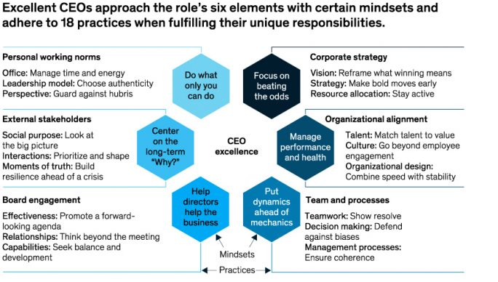

**What are the unique responsibilities of Leadership?**

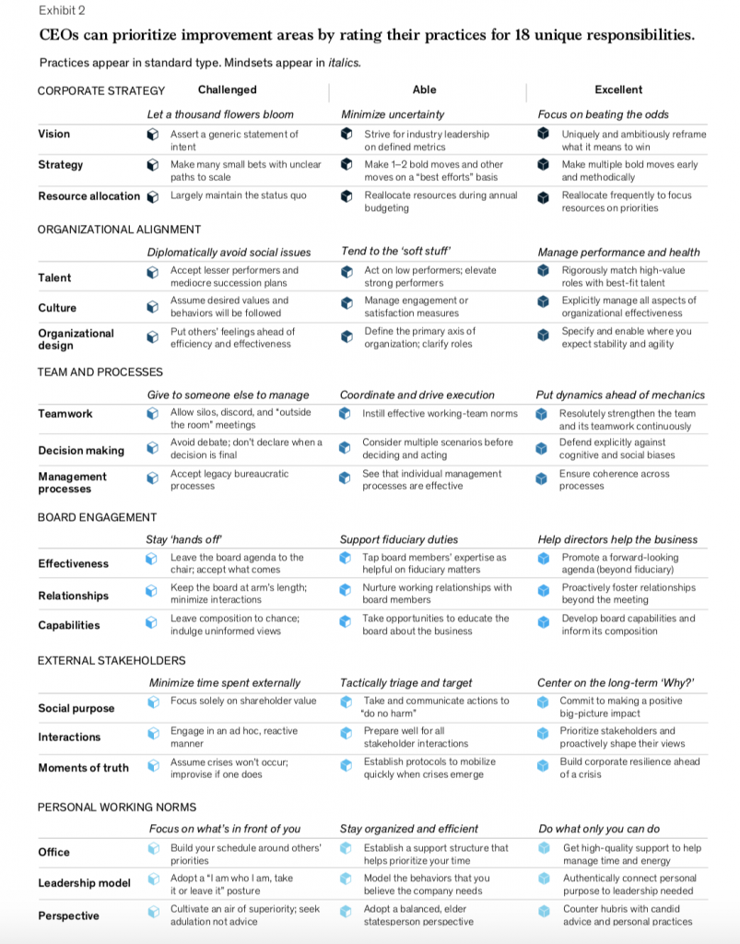

# 12. Digital Leadership

**What is Digital leadership?**

Digital Leadership provides your organization the ability to maximize & scale your business and create success in digital business.

The top-level value of digital leadership is: -

**1. Builds a Digital Culture**– Different departments within a business will require different digital tools to improve their work. Having an effective digital leader helps to make this happen within your organization by giving teams access to the right tools at the right time.

Example: Let’s take Google Drive as an example. Companies can use Google Drive to create and access documents containing specific data. Additionally, employees that work remotely can collaborate and share documents via this platform. Each edit that is made is saved and people can see who added, removed or changed any information in real-time.

**2. Enables Employee Productivity**– The tools provided to your organization are designed to increase productivity levels, however, without digital leadership to drive this, employees could struggle to implement and get the most out of these tools. Digital leadership ensures that your workforce can focus on using technology safely and in line with business needs.

**3. Improves customer satisfaction**– A satisfied customer will have no reason to leave your business for a competitor, but a dissatisfied one will have many. Digital leadership can help this by improving convenience, speed and customer support opportunities. This will make a customer increasingly satisfied with your product or service.

**4. Increases revenue**– Serving many customers quickly is the best recipe to make more money for your business and there are many ways that digital leadership can encourage this:

* **Improving Retention Rate**: when you can better serve your customers with digital tools, they become increasingly satisfied and turn into loyal customers.
* **Increasing the Number of Customers Served:** digital tools help you to serve your customers at a lower operational cost.

**What are the Digital Leadership Skills?**

In today’s world, digital leadership is an obvious balancing act that requires a unique set of skills to drive success for the leader in question, their organization and overall workforce.

**Communication** – Through technology, digital leaders can build a strong network of communication from the top to the bottom of the business. To implement this, digital leaders must have a strategy in place and understand who they are addressing. Example: Virtual meetings. Considering that managers have tight schedules and can be out of town, virtual meetings enable them to attend meetings within their company virtually. This way they are updated with the latest changes and can communicate any information virtually.

**Vision** – With a clearly defined vision it’s easier to get your workforce onboard with the needs and expectations of the business, as they’ll come to believe what you know. This is one of the pivotal traits that makes digital leaders stand out from the rest.

**Digital Literacy**– Organizations know that their businesses are being disrupted and reinvented by digital business models, but many do not believe they possess the skills, leader or operating structure to adapt. We need executives that are aware of these needs in the business. As Deloitte put it, we need a “different kind of leader,” one that is younger, more agile and aware of the various challenges that may well face them in their role.

**Strategy**– The most successful digital leaders will not only have a very clear vision for the future, but also a strategy in place that helps them to nurture a digital culture internally, one that’s ready to embrace change. In order for this to actually happen, a coherent strategy outlining the digital agenda is crucial.

**Innovation** – The digital landscape is ever-evolving and leadership must be willing to try out new technologies that help their teams to grow. In order to do so, leaders need to be flexible and adaptable with their approach in creating a digital workforce. There will be calculated risks, e.g. adopting new tech before competitors or results, but the rewards could be of great value. This leads directly into the next point, risk-taking.

**Risk-Taking**– Putting speed and innovation ahead of tried and tested technology is something that organizations must be cautious of, however, risk taking is a crucial part of digital leadership. This was supported by Mark Zuckerberg, CEO of Facebook, who stated that “the biggest risk is not taking any risk. In a world that is changing really quickly, the only strategy that is guaranteed to fail is not taking risks”.

**Adaptability** – When changes occur in an industry or business it’s important that a digital leader can remain adaptable and ready to make decisions that will reduce impact on the business. A leader who is unwilling to change or be proactive will condemn the business.

**Talent Spotting**– Digital leaders need to be able to spot the areas within their business that need to be improved and where talent is lacking. People are just as crucial as technology.

**What is the Roadmap for Digital Leadership?**

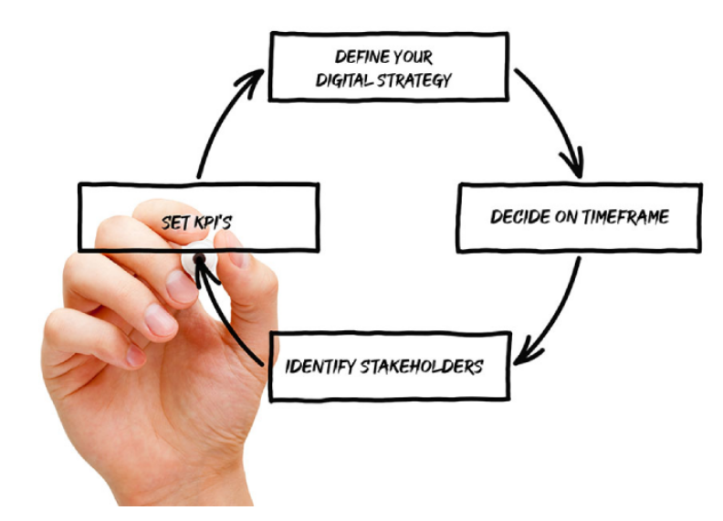

**Define your digital strategy**– you need to start with a clear vision of exactly what you want your digital strategy to achieve. This could be things such as brand amplification, increase sales revenue or improve customer experience. Take these goals and define your digital strategy.

**Decide on timeframe**– once you have your strategy written and defined it’s important to decide when you’d like to achieve it by. Your digital roadmap should outline when you want elements of the project complete and the overall project. It’s important to be realistic too.

**Identify stakeholders**– in order for your roadmap to be a success, you need to define who will be responsible for what and keeping it on track. The digital leader needs to ensure the stakeholder is invested and engaged in the strategy too.

**Set KPI’s**– this is vital if you want to assess and measure the success of your strategy and also recognize when elements are falling behind and might need to evolve. Data is crucial to this.

**Who is Digital Leader? What are the traits of a Digital Leader?**

Digital-ready leaders lay the foundation of digital transformation, and streamline organizations in a way that allows them to reap maximum benefits out of disruptions. They support and inspire employees to change the way they work, they revolutionize their processes, increase profitability, and lead their organizations to phenomenal success.

Let’s take a look at a few traits that all digital-ready leaders possess.

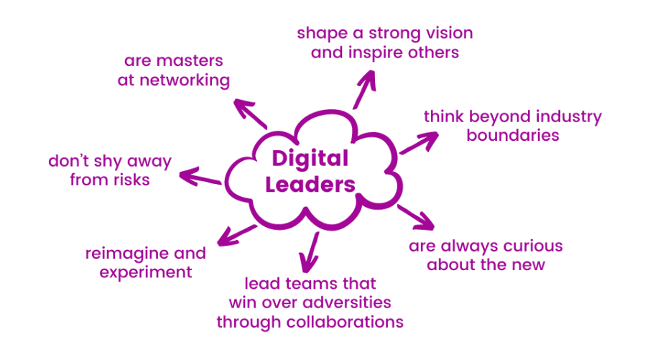

**What are the Seven Building Blocks of Digital Transformation?**

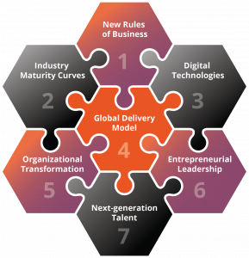

**Bibliography**

**Books for References**

|  |  |
| --- | --- |
|  | CEO Excellence – Carolyn Dewar, Scott Keller, Vikram Malhotra  Winning in the Digital Age – Nitin Seth  7 Habits of Highly Effective People - Stephen R. Covey  Leadership Essentials – Dr. Carrie A. Picadri |

**Website for References**

|  |  |  |
| --- | --- | --- |
|  | What is Leadership? Definition, Meaning & Importance  https://emeritus.org/in/learn/what-is-leadership/  Leadership Vs Management  https://pmstudycircle.com/leadership-vs-management/  12 disciplines of Leadership Excellence  https://www.linkedin.com/pulse/12-disciplines-leadership-excellence-itd-world-vietnam  51 Rules for Leadership Excellence  https://www.inc.com/marla-tabaka/51-no-fail-rules-for-leadership-excellence.html  Leader Traits - What Makes an Effective Leader?  https://courses.lumenlearning.com/suny-principlesmanagement/chapter/what-makes-an-effective-leader/  The Six Mindsets That Distinguish the Best Leaders from the Rest  https://www.leadershipnow.com/leadingblog/2022/03/the_six_mindsets_that_distingu.html  Five Ways To Be An Influential Leader  https://www.forbes.com/sites/benjaminlaker/2021/02/09/five-ways-to-be-an-influential-leader/?sh=6c36963a1d97  Top Great Leaders of the World  https://leverageedu.com/blog/great-leaders-of-the-world/  https://sugermint.com/leadership-qualities-of-narendra-modi/  Leadership Powers  https://www.betterup.com/blog/types-of-power  Digital Leadership  https://digitalleadership.com/  https://gdsgroup.com/insights/article/what-is-digital-leadership/  https://quixy.com/blog/7-traits-of-successful-digital-leaders/  Leadership Theories  https://corporatefinanceinstitute.com/resources/management/leadership-theories/  Contingency Theory of Leadership  https://www.villanovau.com/resources/leadership/contingency-theory-leadership/  Leader-Member Exchange Theory  https://www.mindtools.com/pages/article/leader-member-exchange.htm  Power Tactics  https://www.toppr.com/guides/fundamentals-of-economics-and-management/organising/the-concept-of-power/#:~:text=The%209%20influence%20tactics%20are,%2C%20ingratiation%2C%20pressure%20and%20coalitions  Developing Leadership Character  https://iveybusinessjournal.com/publication/developing-leadership-character/  Ethical leadership principles  https://harperfoxpartners.com/principles-of-ethical-leaders/#:~:text=According%20to%20scholars%20and%20practitioners,at%20these%20in%20more%20detail.&text=Ethical%20leaders%20really%20listen%20to,their%20views%20do%20not%20align  Leadership Communication  https://online.hbs.edu/blog/post/leadership-communication  Team Leadership  https://leaders.com/articles/leadership/team-leadership/  organizational leadership  https://www.betterup.com/blog/what-is-organizational-leadership-and-why-is-it-important | |
| **A Leader is a Dealer in hope**  Image result for leadership excellence  **Leadership is an influence** | |